# Chapter 1 -Introduction

## 1.1 – Introduction of System

The project library Management System is library management software for observing and governing the transaction in a library. The project “library management system” is develop in PHP language, which will be mainly focuses on basic operations in a library like adding new member, new books, updating new information, searching books and members and facility to borrow and return books and MySQL database for recording the users and library data.

## 1.2 – Background of System

The main purpose for choosing library management system is to upgrade manual system into computerized system. In manual system people may find difficult to handle library operation like keep records regarding books and student borrowers etc. So, in manual system record keeping is not reliable there is high chance of data redundancy and data loss. On the other hand it needs lots of worker to manage library which may cost a lot. On borrower’s point of view, in manual system they can’t find the book exactly what they needed and sometimes they searched book that is not available in the library which may lose their time.

So, therefore to make library efficient, reliable I plan to upgrade manual system into computerized system and also to overcome the weakness of manual system.

### 1.2.1 – Problem statement

* Upgrading manual system into computerized system for recording library data.
* Reducing cost for managing library.
* Have proper record of database of a user and less chance of having data redundancy
* Can have user friendly admin and user login interface.
* Have proper communication between Librarians and member.

## 1.3 – Justification of Project

A good library management system improves the effectiveness of the librarians and library users and also provide service to member. It also helps to permits librarians to easily list books and keep proper records of books issued, reissued and those not return and it will also help to check the availability of any books that library might need. A good library management system helps to save the time, it increase the productivity of library workers, it reduces the cost of managing a library and at last it improves the presentation of the library.

## 1.4 – Overview of Purposed System

Library management system is windows application written for windows operating system, planned to help users to preserve and unify library. This software is easy to use for both beginners and advanced users. It have features like, having an attractive user interface, joint with strong searching attachment and reporting capabilities. The library system helps to get a good idea of which are the books borrowed by the members and also checks which book are not available in library. The project is concerned with developing a library management system using object oriented programming language.

## Scope

## 1.5 – Aim

The following aim for this project are given below:

* The main objective of Library management System is to increase and upgrade the prevailing system by growing its productivity and efficiency.
* The software increases the working approaches by substituting the current manual system with the computer-based system.

## 1.6 – Objective of Project

The following objective for this project are given below:

* The objective of the library management system is to handle the whole action of a library.
* Improve a system that can substitute the manual library management system into computerized system.
* Improve a database which stores user information and book information with trustworthy search capability.
* Should have good-looking user interface to navigate through the system with having user friendly environment for user.
* Separate logins for both administrator (librarian) and users. So that admin can issue and return books, add/edit/search/delete books and user details whereas user can search the books and view their details.

## 1.7 – Features to Be Included

The following features that are available to librarian are:

* A librarian can issue a book to the member.
* Can view the list of books available in group.
* Can have access to all the account of the student.
* Edit the information of books.
* Add books and their information to the database.
* Can take the book returned from students.
* Can have librarian control panel which allow them to add, remove, edit the books.

The following features that are available to member are:

* Can view different group of books available in the library.
* Can view the list of books available in group.
* Can own an account in library.
* Can view books issued to him.
* Can search for particular book.

The following features that system needs:

* Easy and user friendly login interface.
* Proper monitoring by the administrator which includes updating account status, showing message if user attempt to issue more than one books.
* Assigning fine if member skip the date of return.

## 1.8 – Overview of the Scope

* The main reason for having library management system is to provide book information to member and employee of library.
* This system also provide information to member which books are available in library and which books members will able to issue for reading purpose.
* In this library management system anyone can become member to read books by filling a member form.

# Chapter 2: Analysis

## 2.1 Description of Analysis

Analysis is the detailed examination of the elements or structure of something. It is process of determining the strength and weaknesses of particular matter. In this project analysis is done to gather information for the system. As we know analysis tells us what our system should do. It is a process of understanding a project domain and defining the project scope. So basically project domain features the logic, data, assumptions and understanding that go with a particular problem and project scope means how much of a problem your system is going to address.

Analysis plays important role while developing the project. Analysis provide description of all aspects of the system and description of any problems that exist. While conducting analysis it helps to identify problems and helps to organizing the facts and details of a system. Analysis helps developers to figure out the software requirement, design etc. By conducting analysis it helps to know what works with what, what causes something fail, and what can work independently.

## 2.2 Analysis Methodology

Methodology means steps that need to be monitored when working on a task/project and in what order they should be taken. In other words it is also defined as the steps taken when gathering data, investigating data and documenting requirements. Methodology offers an arrangement to monitor when working on project and makes the analysis and design more controllable. It helps to determine whether the project need to be done on technical consideration, user consideration and organizational thoughts.

There are several methodology available for the analysis and development of system. Among them I choose hard system methodology.

Hard approach system analysis refers to taking highly structured approach to analysis of information system. Hard approach follows a logical sequence of steps and follows to rules, guidelines and standards. Mainly hard approach is appropriate to use when working on large and complex information system as well as it is useful for small information system projects.

The main reason for choosing hard approach over other approach are-

* A hard approach takes a highly structured approach to information system analysis.
* It follows a logical sequence of steps.
* It facilitate progress to be measured by referring to objectives that are defied for each steps.
* It ensures thorough planning and scheduling.
* It focus on technical requirements.
* It is likely to be undertaken quicker than other methods. Example, like soft analysis approach.
* It is likely to be less expensive than other approach.
* Easier to manage than soft systems methods due to clearly defined project phase.

Among the hard approach I choose structured system analysis and design methodology (SSAMD). This methodology is similar as waterfall model and useful for small project just like mine.

SSAMD can be used to look in detail at three views of a system:

* **The Process View 🡪**

In this process view it defines the functions that have been carried out by an information system. Mainly in this view it checks how data is moved around system and also ensures how system changes as it is managed.

* **The Data View 🡪**

In this data view it defines the data and information that the system practices.

* **The Event View 🡪**

In the event view it defines the events that agreed the methods running and the consequence of outdoor events on the data.

If SSAMD is started thoroughly, then it helps to generate well-documented and correct information system. This methodology is similar as waterfall model which is very simple and easy to understand. Similar to waterfall model in this methodology each phase must be fully completed before the next phase can begin. Here are the following steps of SSAMD:

* **Feasibility study** 🡪

Feasibility study helps to determines and examines whether the project is socially, operationally, technically, legally and financially feasible or not. It also helps to determine the cost effective of the project and also helps to analyze the drawback of existing system.

* **Analysis and Requirements Specification 🡪**

In analysis and requirements specifications all the features of the system are analyzed like hardware and the software of the system and later on the requirements are defined to produce the technical specification.

* **Design 🡪**

The main purpose of design phase is to change the requirements into complete and thorough system design terms.

* **Implementation 🡪**

In this phase where visions and plans become reality. In this phase it ensure the final deliverable meets the acceptance set by client. As well as system is introduced to the organization directly with the existing system.

* **Testing 🡪**

In this phase where all the aspects of the system are tested to ensure the usability, robustness, security and reliability of the system.

* **Maintenance 🡪**

It is the process of making changes to the hardware, software to support and ensures the robustness and reliability of the system. It means making changes to improve the performance, security of the system.

**Data Flow Diagram**

It shows the flow of data in and out of the system and also helps in data processing. Data flow modelling is the technique of SSAMD which mainly focuses on how model and documents moves around the information system. It also check what changes data and where it is stored and how data enter and leaves the system. So, DFD refers to data flow diagram.

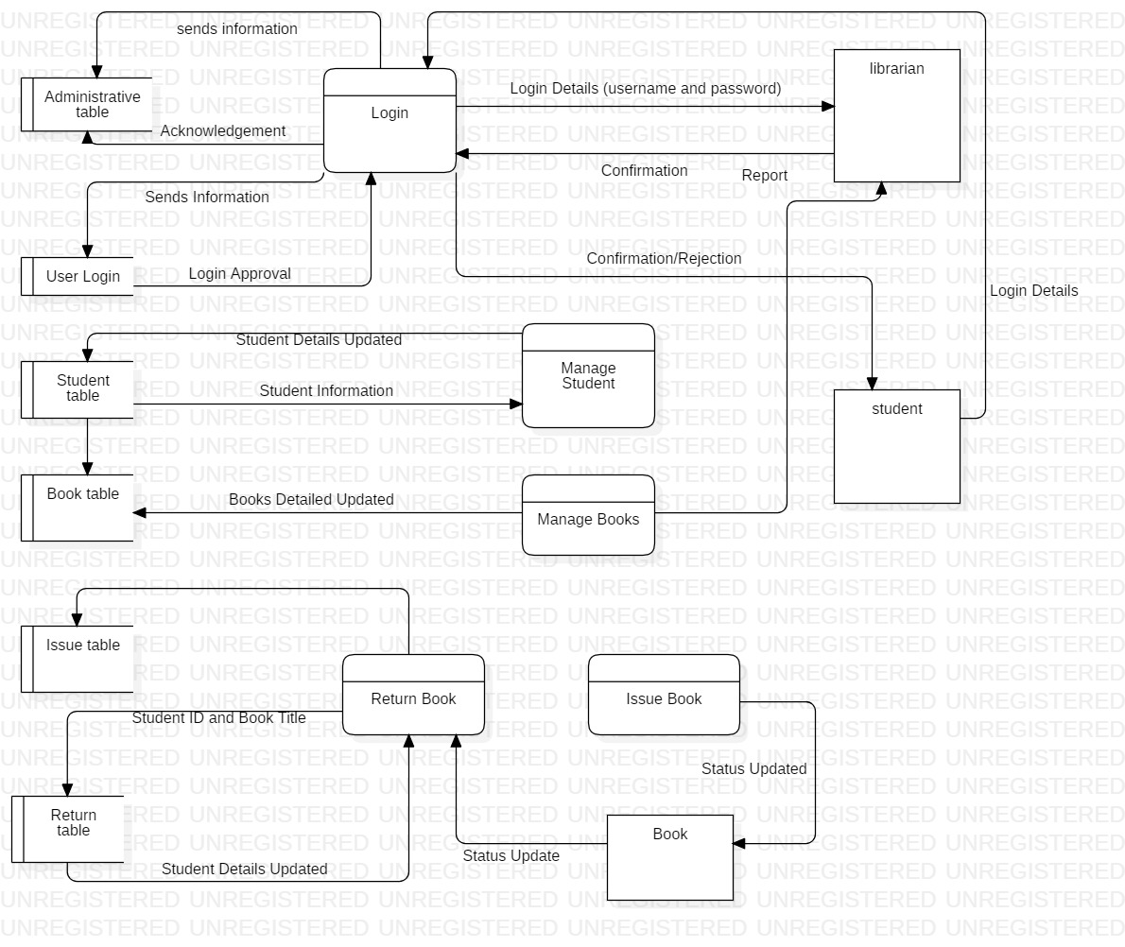

Figure Data Flow Diagram of Library Management System

## 2.3 Information Gathering Method

Information gathering method is also a part of analysis. We collect information from different source. The information which are meaningful are collected and according to those information planning of the project is done.

The information gather method are-

* Interview
* Questionnaire
* Feedback
* Survey
* Focus group
* Documentation
* Observation

Among these information gather method I choose interview and survey.

**Interview**

Interview is a conservation where question are asked and answer are given. It is one of the simple and easy way to gather the information about any project. Therefore, I have prepare some question that will cover overall information needed while developing library management system.

**Purpose of the interview**

The main purpose of the interview is to gather, identify problems and requirements regarding a software system for the library management system.

**Agenda**

* Changing the manual based library system into computer based system or not.
* Does library system provide search facility for each books, articles and magazine?

So, for interview I have chosen librarian and student for interview.

* **Interview with librarian**

**Interview taken date: July 25, 2019**

**Time: 11:30 AM**

**Duration: 30 minutes**

**Librarian name: Kapil Pandey**

**Question asked in interview:**

* How would you promote student for reading books?
* Is student find user friendly interface while searching books, article?
* Is student find books, newspaper, and article according to in sequence order?
* How do you record book, article detail and information?
* Does your library open 24 hours for student?
* What system is being used to store library student detail?
* Does system can perform functionality like add, delete, and update?
* **Interview with student**

**Interview taken date: July 25, 2019**

**Time: 1:00 PM**

**Duration: 30 minutes**

**Library user name: Suresh Shrestha**

**Question asked in interview:**

* Do you find difficult to search books and article?
* Do existing system have user friendly interface?
* Do librarians helps you to find information they need?
* Do you get borrowing books facility?
* Do you guys get security and confidentiality of your data and information?
* Do you guys get fined if you not return books in time?

**Survey**

In survey comprehensive information is gathered from a targeted audience and conduct research on the basic of collected data. Therefore, I have prepare some question that will cover overall information needed while developing library management system.

So, for survey I have chosen student and librarian:

**Student**

* How satisfied are you with information and research service provided by library?
* Very satisfied
* Satisfied
* Dissatisfied
* Very dissatisfied
* How satisfied are you with the availability of library provides books, article?
  + Very satisfied
  + Satisfied
  + Dissatisfied
  + Very dissatisfied
* Are you able to get check return date and issue date of books that’s you are looking for?
  + Absolutely yes
  + Yes
  + No
  + I don’t know
* If system provide search facility for book or not?
  + Yes
  + No
* Do you guys can create your own account while accessing library?
  + Yes
  + No
* Do you guys view different group of books like (magazine/newspaper/books) available in the library?
  + Yes
  + No
* If you have any comments or suggestion on how we can improve our service. Please tell us below:

**Librarian**

* If system provides member fine for late returning of books or not?
  + Yes
  + No
* If system provides issue books or not?
  + Yes
  + No
* If system provides database backup and restore facility or not?
  + Yes
  + No
* If system provides modification of record at any time while adding or deleting books or not?
  + Yes
  + No
* If system provides check out/ check in of a books or not?
  + Yes
  + No
* If system provides add/edit/delete/update function for recording the user information or not?
  + Yes
  + No
* If system provides update function for recording the books or not?
  + Yes
  + No
* If you have any comments or suggestion on how we can improve our service. Please tell us below:

## 2.4 feasibility study

Feasibility study examines and determines whether a project is technically, financially and socially feasible or not and also helps to analyze the drawback of existing system. It also helps to determine whether the project is cost effective or not. It also conduct cost-benefit analysis to determine cost and benefit of a project. The project where feasibility study is conducted would able to implement to success as it was carefully planned.

The different type of feasibility study are as follows:

* Technical feasibility 🡪

In technical feasibility study, one has to check whether the projected system can be settled using existing technology or not. It is planned to implement the system using windows 8, apache web server. Since my project is web based application so by use of pc, laptop and mobile device user can find easier to use web application through browser.

* Economic feasibility 🡪

In economic feasibility study it checks the efficiency of a project. It perform cost and benefit analysis which helps to identifying profit and cost from the project called library management system. In this study cost and time are most essential factors.

* legal feasibility 🡪

Legal feasibility is the study to know whether the project confirm the legal and ethical requirements. While developing library management system does this project include licenses, copyrights, contract extension agreement, guarantee agreement etc.? The main objective of this study is to ensure that the project is legally done.

* Time feasibility 🡪

A time feasibility study is the period of time, within it a software should produce relevant answer. So in the given project I have given around 120 days to complete the project. So within the time given by client the product should be deliverable if it takes too long to be completed before it is useful, then the project is meaningless. It is necessary to determine the deadlines.

* Social feasibility 🡪

In this feasibility study where the approval of people is measured concerning the product to be launched. In the social feasibility study if the project hampers the social environment then developing the project doesn’t give any meaning. So by conducting social feasibility study we can know the negative impact that may arise in social environment while developing project.

## 2.5 SRS (Software Requirements Specification)

A software requirements specifications is a documents that defines what the software will do and how it will be expected to perform. The main purpose of conducting SRS is to define the functionality of the product requirements and to fulfill all stakeholders’ requirements. The two requirements are:

**Functional requirements 🡪**

Functional requirements are those requirements that are related to the technical functionality of the system. In simple language functional requirements are those requirements which are needed compulsory to run the system example like login, registration etc. it is also defines as the functionality of the software, which the software engineers have to improve so that the customers could simply accomplish their job up to the business requirements.

Here are the functional requirements for library management system

|  |  |  |  |  |
| --- | --- | --- | --- | --- |
| ID | Title | Description | Rational | Dependency |
| K1 | Registration | By the help of registration student can login and able to operate the features of the system | To get login into the system and to use the features of the system. If student can’t create their account, then they can’t login and use feature of system. | N/A |
| K2 | Login | It is process of logging into the system and used to gain access of the system in secure way. | By the help of login student can search and read the books, article and magazine of the library. If user verification is authorized then student can have access to the system | K1 |
| K3 | Add new books | To know the about different kinds of books available in library | By adding books in library student can get variety of information in different field | K2 |
| K4 | Search books | To checks the availability of books in library | Student can search and view about books available in library. | K2, K3 |
| K5 | Edit books | To change the books details | If any changes required in issue books then edit books helps to edit the details. | K2, K3, K4 |
| K6 | Delete books | Delete helps to remove the all the information of books that has been return in context of library | The books details will be removed. | K2, K4, K5 |
| K7 | Remove student user | By remove user it prevents user for accessing the system | Admin can remove the user which doesn’t want to get access of the system. | K1 |
| K8 | Issue books details | It helps to record the books that has been issued by the user. | By having issued books details one can check the availability of the same books. | K2, K4 |
| K9 | Return books details | It helps to checks whether user return respective book that are issued or not. | By having return books details one can check the book details | K2, K4, K8 |
| K10 | Update books details | It helps to add additional feature and function in the system. | By having update functionality user can update the information of books, magazine | K4, K5 |
| K11 | Late fine report | Those student who doesn’t return books after their expiry date | If student doesn’t return books on time then they will be penalized. | K9 |
| K12 | Update student account | It helps to update student personal details in system | By this functionality student can update their account | K2 |
| K13 | View records of book issued | It helps to view the record of books that will be issued to the student. | By viewing records of issued books it helps to checks the availability of books. | K4, K8 |
| K14 | View records of book return | It helps to view the record of return books details | By viewing records of return books it helps to checks the availability of books. | K4, K8, K13 |
| K15 | Books are categorized according to its department | It helps to arrange books and magazine according to its catalog | By arranging books according to its order it makes easier to search books. | K4 |

**Non-Functional Requirements 🡪**

Non-functional requirements are those requirements that defines how the system work. It mainly focuses on the quality of the system. Attribute such as security, reliability, performance, maintainability, scalability and usability are lies in non-functional requirements. Actually in simple terms non-functional requirements are those requirements that helps to verify the performance of the software. It concentrates on the users expectations and captured quality attribute.

Here are the functional requirements for library management system

|  |  |  |
| --- | --- | --- |
| ID | Title | Description |
| KP1 | Usability | The system should use proper navigation bar to guide the student to use the system. To use the system easily student should provide online user guide for reference and help. |
| KP2 | Availability | The system should be available to student for 24 hours. As well as library should available library resources likes books, magazine etc. for 24 hours? |
| KP3 | Reliability | The system has to be 100% reliable. The system quality should be trustworthy. Data integrity and confidentiality must be maintained and data should be reliable. |
| KP4 | Accuracy | The system should accurately provide real time information taking into consideration various concurrency issues. |
| KP5 | Efficiency | Even if the system fails, the system should maintained backup. By help of efficiency, it looks at what current system is produced and compares with what could be achieved with the existing resource. |
| KP6 | Security | When student want to use library website they must be authenticate by the system to avoid fraud and hacker. Only valid users must allow to access the system. |
| KP7 | Maintainability and Portability | The system must be flexible and also allow modification of the system if needed. The system should provide the notification message to student if any books is overdue.  System must cope with changes that occur in system. |
| KP8 | Performance | It is an act of performing a task or function. The developed system should be free from lags and system must respond with the student at the real time speed |

**MoSCoW Prioritization 🡪**

Prioritization means doing first thing first, it means evaluating a group of items and ranking them in their order of importance. MoSCoW prioritization is used to prioritize the requirements of the software. MoSCoW stands for must have, should have, could have, and won’t have.

In Must have 🡪 the project cannot completed without completing this prioritize requirement.

Should have 🡪 requirements which have high priority is done or included.

Could have 🡪 without having this requirement system will run.

Won’t have 🡪 requirement could be useful for future use.

MoSCoW prioritization for functional requirements

|  |  |  |  |  |
| --- | --- | --- | --- | --- |
| ID | Requirement | MoSCoW | Rational | Remarks |
| K1 | Registration and sign up system | Must have | To make system confidentiality, integrity by allowing verified student to access to the system |  |
| K2 | Login | Must have | It is required to authenticate the valid student to access system. |  |
| K3 | Adding new books | Should have | It provides the newly arrived books in library. |  |
| K4 | Search books | Should have | It helps student easier to search books that they want. |  |
| K5 | Edit books | Must have | It is the fundamental function within the system. |  |
| K6 | Delete books | Must have | It is the fundamental function within the system. |  |
| K7 | Remove student user | Must have | This functionality helps to maintain the confidentiality data of the system |  |
| K8 | Issue books details | Must have | It is functional requirement of the system which helps to check availability of books. |  |
| K9 | Return books details | Must have | It is functional requirement of the system which helps to check availability of books. |  |
| K10 | Update books details | Must have | For convenient data handling |  |
| K11 | Late fine report | Could have | It is one of the important requirement given by client so it must include in system. |  |
| K12 | Update student account | Should have | It helps to edit the student details. |  |
| K13 | View records of book issued | Could have | Admin can view the issued books details which helps to record the details of books. It increase availability of books. |  |
| K14 | View records of book return | Could have | Admin can view the return books details which helps to record the details of books. It increase availability of books. |  |
| K15 | Books are categorized according to its department | Must have | This functionality helps student to search books easier and save student while searching books time. |  |

MoSCoW prioritization for functional requirements

|  |  |  |  |  |
| --- | --- | --- | --- | --- |
| ID | Requirement | MoSCoW | Rational | Remarks |
| KP1 | Usability | Must have | Every system should be useable to fulfill the needs of user or client. |  |
| KP2 | Availability | Must have | System should provide books and information anytime while accessing the system. |  |
| KP3 | Reliability | Could have | System could not be 100% perfect. So to avoid these kind of bugs and errors should try to make quality of service to student. |  |
| KP4 | Accuracy | Must have | System should be correct to provide service to the student. |  |
| KP5 | Efficiency | Must have | System must provide the efficient performance to the student while accessing the system. |  |
| KP6 | Security | Must have | Data security is one of the important aspect of system. So to maintain student data system should provide security in it. |  |
| KP7 | Maintainability and Portability | Should have | System itself should be helpful with the system and help to cooperate with problems. |  |
| KP8 | Performance | Must have | With the increase of new technology system should free from lags and should give high performance while accessing the system. |  |

**Hardware and Software Specification**

**Hardware Specification**

* Processor 🡪 32-bit, dual-core, 1.5 GHz minimum per core
* Ram 🡪 4 Gb
* Hard disk 🡪 80 GB for installation of all project software.

**Software Specification**

* Windows operating system 7 or higher.
* Database server (SQL)
* Apache server
* Brackets/ notepad
* Star UML

## 2.5 Use Case Diagram

A use case diagram is a graphic representation of the connections among the components of the system. It is a methodology used in system to classify, explain and unify system requirements.

Use case diagram specific purpose is to gather the system requirements and actors. It specify the events of a system and their flows. The main objective of use case diagram is it make easy to know about the functional requirements of the system and also make it easy to recognize the various connections between the users and the system.

**Actor 1: librarian and admin** 🡪

These actor helps to manage the library, these actor plays vital role in the system, their main role is to add book, add student, issue book, return book, manage student, issue and book report, penalty report, history etc. similarly in library these actor used crud operation to record the details of books and student.

**Actor 2: student** 🡪

Firstly these actor are not registered in the system after the registration these actor can accessed the function of the system. This actor can read the books or take books with them after becoming valid student of the library. These actor can search the books what they want, can see the issue and return report, check history, can see penalty report and can update their profile.

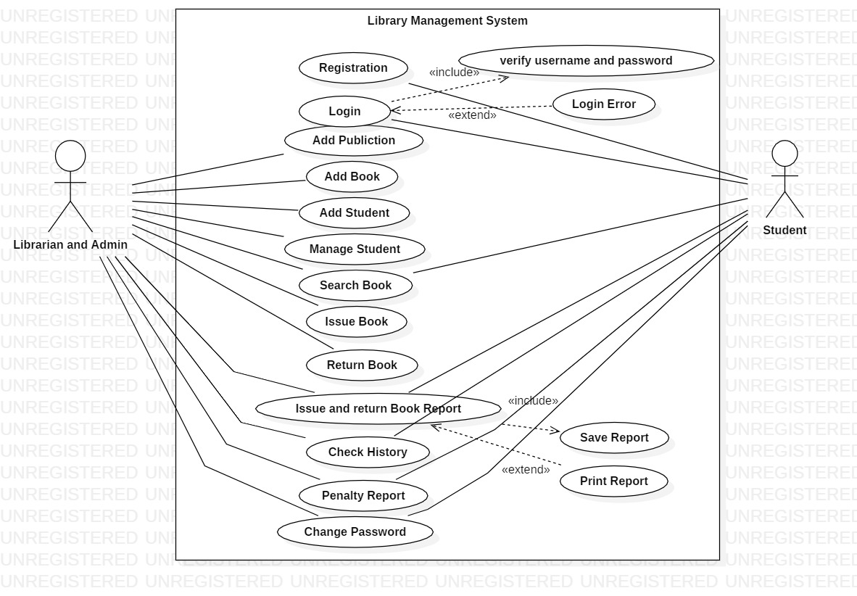

Figure Use Case Diagram of Library Management System

|  |  |  |  |
| --- | --- | --- | --- |
| **ID** | **Use Case Title** | **Summary** | **Actor** |
| K1 | Registration | Student can get access to the system by creating new account. | Student |
| K2 | Login | Student can get valid access to the system and also able to use functionality of system. | Student |
| K3 | Add Publication | Librarian can add the publication records of books. | Librarian |
| K4 | Add Book | Librarians can add newly arrived books in the system. | Librarian |
| K5 | Add Student | Librarians can add the student. | Librarian |
| K6 | Manage Student | Librarians can manage the student. | Librarian |
| K7 | Search Book | Librarians and student can search the books they wanted to read. | Student, librarian |
| K8 | Issue Book | Librarians can issue the books to student. | Librarian |
| K9 | Return Book | Librarians can keep the record of the return books. | Librarian |
| K10 | Issue and Return Book | Librarians and student can view the return and issue books details. | Student, librarian |
| K1 | Check History | Librarians and student can check their previous transaction/ issued books records. | Student, librarian |
| K12 | Penalty Report | Both of them can see late fine report. | Student, librarian |
| K13 | Change Password | Both of them change the password. | Student, librarian |

## 2.6 System architecture

In this scenario project collect information from the user and sends that information into database and again that database will be retrieve. In this way it perform client server system by using 3- tier architecture.

The main reason for using 3 tier architecture in my project:

* It improve the data integrity of system and user.
* It improved the security where user is not directly access to the database.
* It is easy to modify and maintain, and won’t affect other module.
* It gives good application performance.
* It can give better re-use facility.
* It gives high degree of flexibility in deployment platform and configuration of the system.

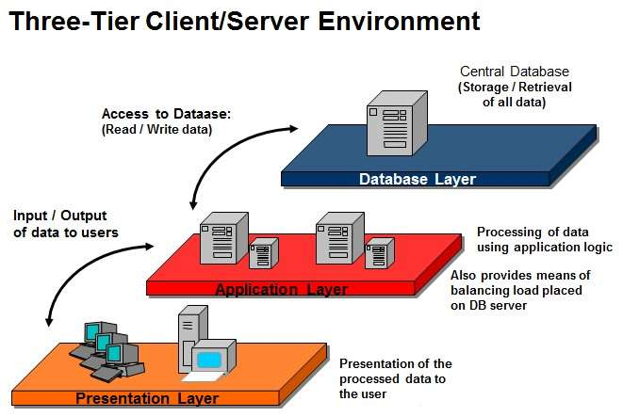 Figure 3-tier architecture model

The three tiers in a three-tier architecture are:

**Presentation Tier**🡪

It conquer upper level data and shows facts related to services offered on a web. The main function of this tier is it attaches with other tiers by delivering results to the browser and other tiers in the network.

**Application Tier**🡪

Application tier is generally also called middle tier or logic tier where information is generally pulled from the presentational tier. It regulate application functionality by implementing complete processing.

**Database Tier**🡪

In data tier generally information or data is retrieved and store in a database server. Data in this tier is preserved independent of application servers or business logic.

**Natural language analysis (NLA)**

Natural language analysis (NLA) is process of identifying nouns, verbs and adjective in a portion of vivid text where noun narrate to potential candidate class, adjective narrate to possible attributes and verb characterize possible actual method.

**Scenario for NLA**

A library management system is a software used to manage the catalog of a library. This helps to keep the records of whole transactions of the books available in the library. A company named ABC wants library management system which is very easy to use and fulfills all the requirement of a librarian and student. The company wants features which helps librarian to keep record of available books as well as issued books. As well as they want to upgrade their manual system into computerized system so they want to have privacy over their student details. Company wants easy and user friendly login interface performance, arranging books according to its publisher, proper monitoring by the administrator/librarians which includes updating account status, showing message if user attempt to issue more than one books and assigning fine if student skip the date of return.

The company wants their software that permits all of this functionality.

* Librarians keep records of different categories like books, journals, newspaper etc.
* Classify the books subject wise.
* A Liberians should have easy way to enter new books.
* Librarians keep record of complete information of books.
* Automatic fine calculation for late returns of books for student.
* Different criteria for searching books for student.
* A librarian can issued a book to the student.
* Librarian can have control panel which allow them to add, remove, edit the books.
* A librarian should record the book returned from students.
* Student can search different books available in the library.
* Student can create their own account.
* Student can view books issued to them.

**Step 1: Listing out class Noun for Candidate classes**

|  |
| --- |
| **Noun selection** |
| Library, system, management, catalog, whole, transaction, books, library, company, library, management, system, easy, fulfills, librarian, student, features, librarians, student, available, manual, system, computerized, performance, system, privacy, student, details, user friendly, proper, administrative, librarian, account, status, fine, librarians, books, journals, newspaper, books, subject, fine, student, librarians, control. |

**Step 2: Reducing synonyms and overlapping classes**

* User, client, student 🡪 student
* software, system, performance 🡪 system
* report, transaction 🡪 report
* library, librarians, administrative 🡪 librarians
* publish, publisher, control, features 🡪 publisher
* books, journals, newspaper 🡪 books

**Step 3: Getting rid of classes that doesn’t cover scope of our project.**

* Catalog, whole, company, easy, fulfills, available, manual, computerized
* Privacy, details, user friendly, proper, fine, subject.

|  |  |  |  |
| --- | --- | --- | --- |
| **S.N** | **Noun identification for class** | **Selected as candidate class** | **Reason for selecting candidate class** |
| 1 | librarian | Yes | It is the fundamental class and suitable for given project. |
| 2 | System | No | Gives similar meaning. |
| 3 | Management | No | Doesn’t give any specific meaning to become candidate class. |
| 4 | transaction | No | Gives similar meaning. |
| 5 | books | Yes | Books are used for reading purpose in library, without having books library is nothing. |
| 6 | Easy | No | It is type of difficulty level. |
| 7 | publisher | Yes | It is used to know the writer of the books. |
| 8 | Student | Yes | Student can read books in the library without student library is nothing? |
| 9 | fine | No | It is out of scope. |
| 10 | Details | No | Gives similar meaning. |
| 11 | User friendly | No | Doesn’t provide any specific meaning. |
| 12 | Subject | No | It is out of scope. |
| 13 | Control | No | Gives similar meaning. |
| 14 | Manual | No | Doesn’t provide any specific meaning. |
| 15 | computerized | No | Gives similar meaning. |

**Step 4: Getting rid of classes finally we get candidate class**

|  |
| --- |
| **Candidate Class** |
| Books |
| Librarians |
| Publisher |
| Student |

**Step 5: Identification of Verb for potential method from scenario**

|  |
| --- |
| **Verb selection** |
| Used, manage, keep, records, wants, use, wants, helps, keep, record, issued, upgrade, wants, arranging, monitoring, updating, showing, assigning, records, classify, add, view, update, record, search, issued, add, remove, delete, edit, return books, issued books, create, view, modify. |

**Step 6: Reducing synonyms and overlapping Verbs**

* Wants, add, keep, use 🡪 add
* Delete, remove 🡪 delete
* Issue, issued books, return books, issued 🡪issue
* Update, edit, modify 🡪 update
* Search, wants, want, monitoring 🡪 search

**Step 7: Getting rid of verb that doesn’t cover scope of our project.**

* Used, records, use, helps, showing, assigning,

|  |  |  |  |
| --- | --- | --- | --- |
| **S.N** | **Verbs** | **Selected as Verb** | **Justification for selecting or rejecting** |
| 1 | Assigning | No | It is out of scope |
| 2 | Add | Yes | It is used to add the book details and student details |
| 3 | Delete | Yes | It is used to delete the book details and student details |
| 4 | Issue | Yes | It is used to record the book details that have been issued to student. |
| 5 | Update | Yes | It is used to update the book details and student details |
| 6 | Search | Yes | It is used to search the book details |
| 7 | Showing | No | Gives similar meaning |
| 8 | helps | No | Doesn’t provide any specific meaning. |

**Step 8: Getting rid of verb finally we get actual verb**

|  |
| --- |
| **Actual verb** |
| Add |
| Delete |
| Issue |
| Update, Search |

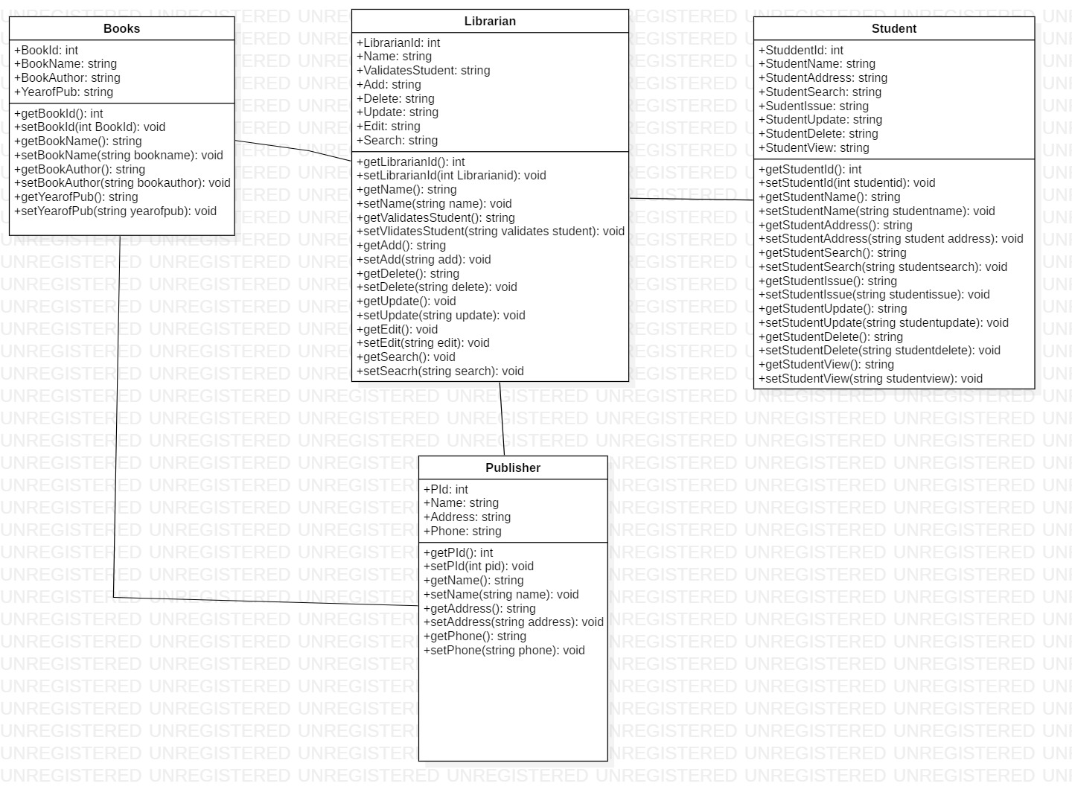

Figure Class Diagram of Library Management System.

# Chapter 3 – Design

# Introduction

Design is a plan or requirement for the building of system for the execution of an activity or process. Design phase describes how the system should be created. System design lies second phase of software development life cycle, after requirement gathering and analysis. The main purpose of design phase is to convert the requirements into whole and comprehensive system. To make design successful in project we must understand the end goal, identify clear roles, collaborate, break it down and look at the past.

The various stages of design phases are structural, behavioral, database and UI modelling.

## 3.1 Structural Modelling

Structural model represent the framework for the system and same framework is placed together where all other component exist. Therefore, class diagram, flowchart, DFD diagram and component diagram are part of structural modelling. It also helps to shows the relationship between classes, object, operation and attribute of the system.

## 3.1.1 Class Diagram

### Definition

Class diagram is a static diagram where it represent the static view of an application. Class diagram is done for constructing executable code for software application. It describes the structure of system by showing the system classes, attributes and relationships among objects.

### Justification

The main purpose of using class diagram is

* It is only diagrams which can be directly diagramed with object-oriented language.
* Class diagram can help to model the static view of an application.
* It also defines the attributes and operation (function) of a class
* It shows a collection of classes, interfaces, association and constraints.

### Notation Used

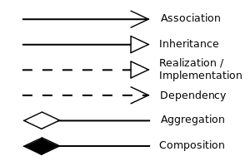

|  |  |
| --- | --- |
| Description | Remarks |
| Association 🡪 it represents a relationship between two classes. It indicates that objects of one class have relationship with objects of another class. |  |
| Inheritance 🡪 it defines the ability of one class (child class) to inherit the identical functionality of another class (parent class). |  |
| Aggregation 🡪 it defines a way of composing different abstractions together in defining class. |  |

### Diagram

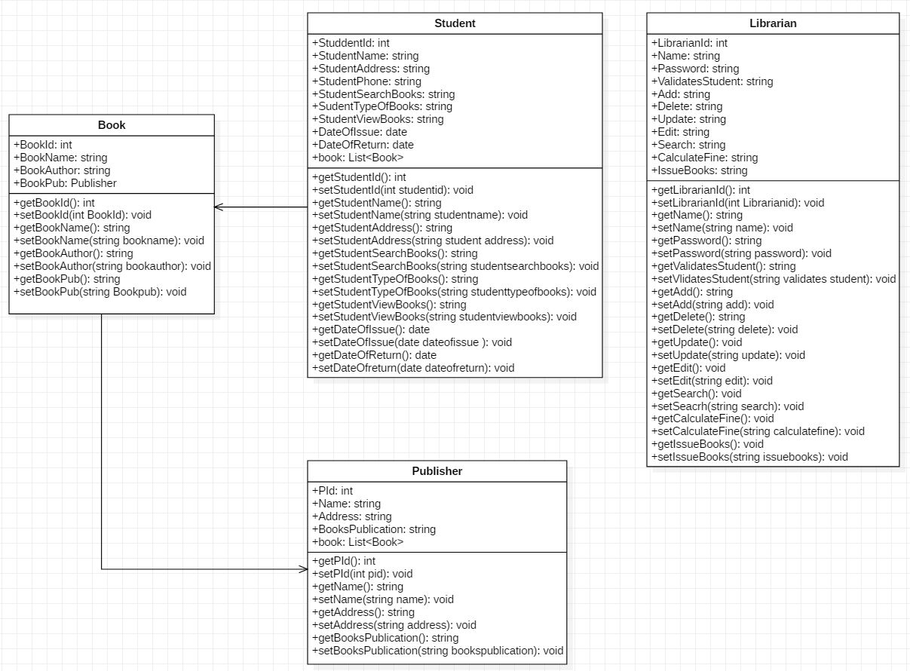

Figure 5 Initial class Diagram

### Diagram Explanation

As shown in the above class diagram each class contains various attributes and functions which appeal other class attributes to share data.

Likewise, in book class it contain attributes such as book name, id, book author, book publication.

In librarian class it contain attributes such as name, password and functions such as add, update, delete, and edit, search and issue books. Also it contain functions like calculate fine etc.

In student class it contain attributes such as student id, name, address, phone number, type of books, date of issue, date of return books, search and view books.

In publisher class it contain attribute such as publisher name, address and year of books publication.

## 3.1.1 DFD Diagram

### Definition

It shows the flow of data in and out of the system and also helps in data processing. Data flow modelling is the technique of SSAMD which mainly focuses on how model and documents moves around the information system. It also check what changes data and where it is stored and how data enter and leaves the system.

### Justification

The main purpose of using DFD diagram is

* It defines the methods that are involved in a system to handover data from the input to the file storage.
* It acts as the starting point for designing the system.
* It defines flow of data through a system to perform certain functionality of a business.

### Notation Used

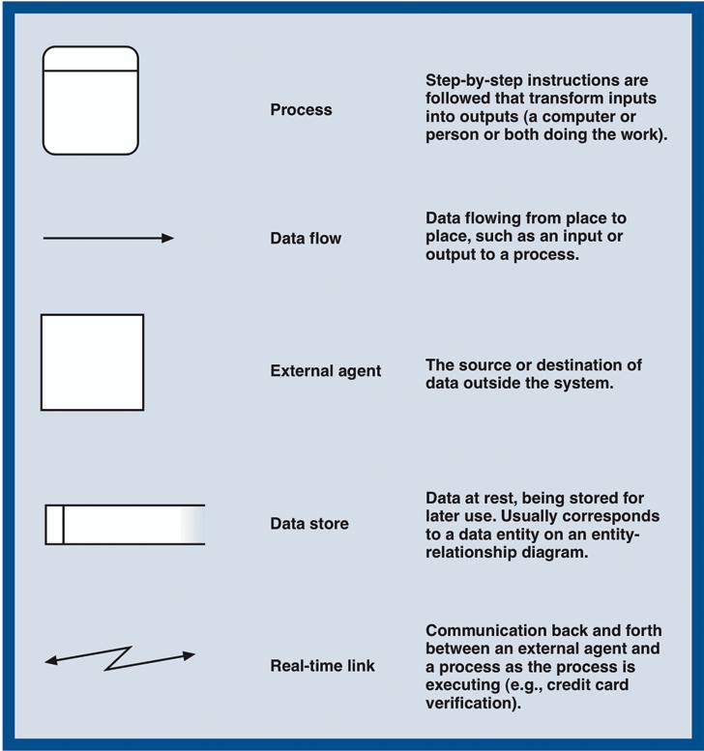

### Diagram



Figure 6 Data Flow Diagram

### Diagram Explanation

As shown in above diagram librarian manage the whole system of library. Firstly librarian insert the username and password to get access of the system. After authenticate login then system provide confirmation message to librarian to access the system. Similarly, student are not authorized to access of the system. But they can view their profile and issued book details. After, successfully login librarian can manage books and student, where separate table is allocated to manage student and books. Similarly, table like issue table and return table is allocated. If student want to issue a books then he/she should give student id and book tile and name. As well as in return table if student return the book then librarian should check book details and his/her expiry date and later should update student detail.

# 3.2 Behavior Modelling

Behavior modelling is also called dynamic modelling. This modelling represent the elements of a system that are reliant on time and deliver the dynamic perceptions of the system and how they relate to each other. This modelling defines how the elements that cooperate to establish a system and interact to provide the functionality of the system and used for system. Activity diagram and sequence diagram are used to show behavior modelling of library management system.

## 3.2.1 Activity Diagram

### Definition

Activity diagram defines the dynamic aspects of the system. Basically, it represent the flow from one activity to another activity and also refers to steps involved in the execution of a use case. In other terms activity diagram can be described as an operation of the system and the control flow is haggard from one operation to another operation.

### Justification

The main purpose of using activity diagram is

* It is used to show message flow from one activity to another activity.
* It describes the parallel, branched and concurrent flow of the system.
* It helps to understand high level functionalities of the systems.
* It is used to build the executable system by using forward and reverse engineering technique.

### Notation Used

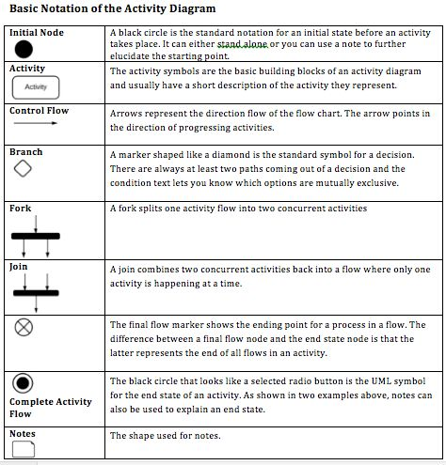

### Diagram

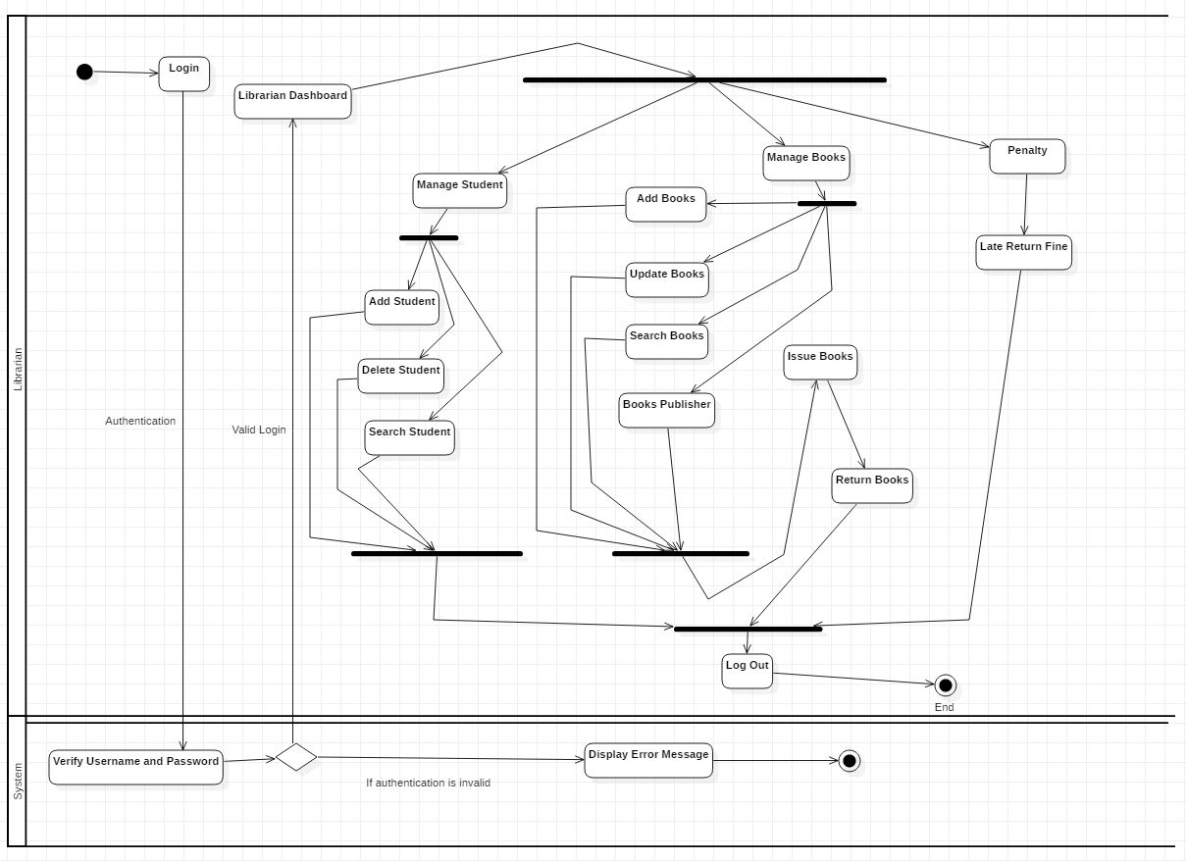

Figure 7 Librarian Activity Diagram

### Diagram Explanation

From the above diagram it shows the librarian activity in the system. Firstly librarian login to the system, then system validates the input data if enter data is valid it display confirmation message otherwise it display error message. After successfully login librarian can manage student, manage books and penalty to student who return book after expiry date. Librarian can add student, delete student, search student in the system.

Similarly, librarian can add books, update books, search books and allocate books according to books publisher. Librarian can able to record the issued book details and return book details

Librarian can also fine to those student who doesn’t return books in time.

### Diagram

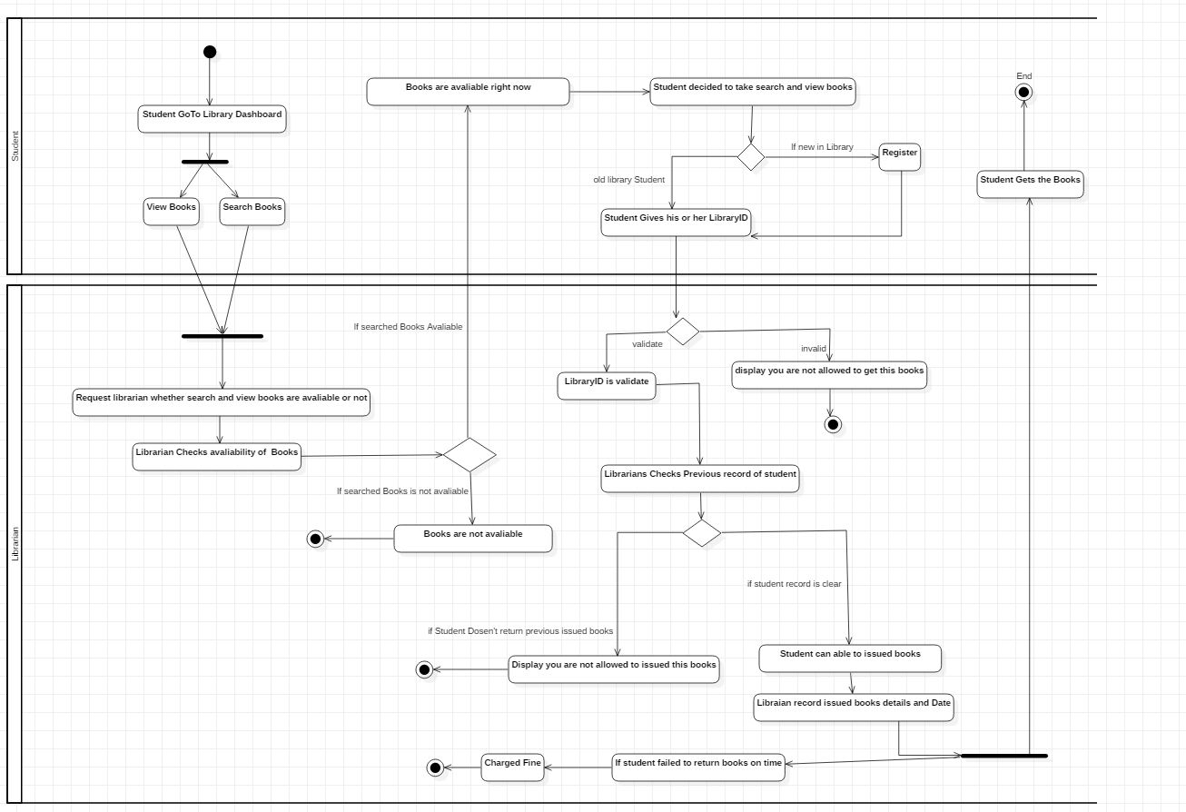

Figure 8 Student Activity Diagram

### Diagram Explanation

As shown in diagram student can view and search in library dashboard. After they find books that they want to read then, he/she request librarian to check the availability of books. If the books is available librarian issued them that books but if that book is not available then librarian gives books not available message to student. If student wants to take available books that they want to read then they should give library card or should become a member in library.

At last librarian checks the student details whether that student failed to return books in past or not. If his/her record is clear then librarian issued books to student and record the issued date details and books details. Likewise, if student failed to return books in time then librarian charged them fine for late return.

## 3.2.2 Sequence Diagram

### Definition

A sequence diagram basically represents interaction between objects in sequential order which means the order in which these interactions take place. Mainly it focuses how and in what order the objects in a system function. Sequence diagram is designed to understand requirements for a new system or to document a current practices. It helps to model the flow of logic within the system.

### Justification

The main purpose of using sequence diagram is

* Sequence diagram is used to document a system’s requirements and to level out a system design.
* It illustration the communication logic between the objects in the system in the time order that the communications take place.
* It helps to understand requirements for a new system or to document an existing process.

### Notation Used

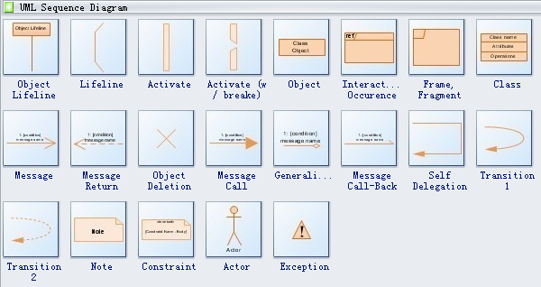

### Diagram

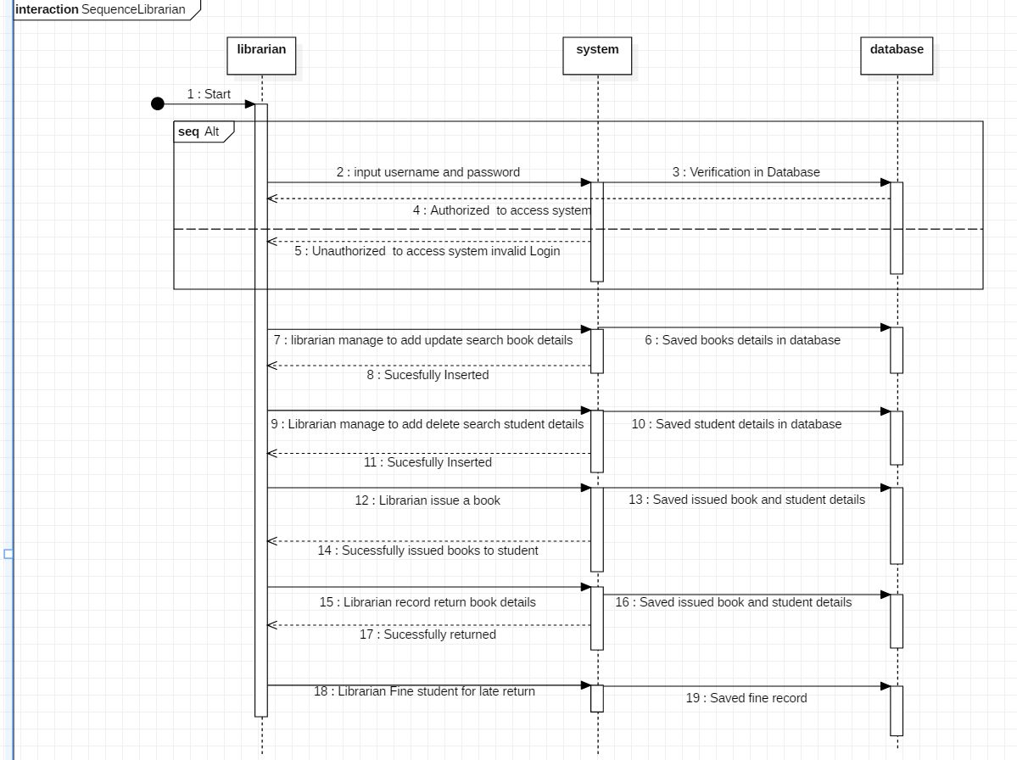

Figure 9 Sequence Diagram of Librarian.

### Diagram Explanation

From the above diagram there are three lifeline which are librarian, system and database. So to access the system firstly librarian login to system if username and password is validate librarian access the system. Otherwise, librarian is not authorized to access the system. Librarian can manage to add, update and search book details and later record books details in database.

Librarian can manage to add, delete and search student details and record student details in database.

Librarian can issued book and record issued books details along with student details.

Librarian can fine student for late return and save fine details of student in the database.

### Diagram

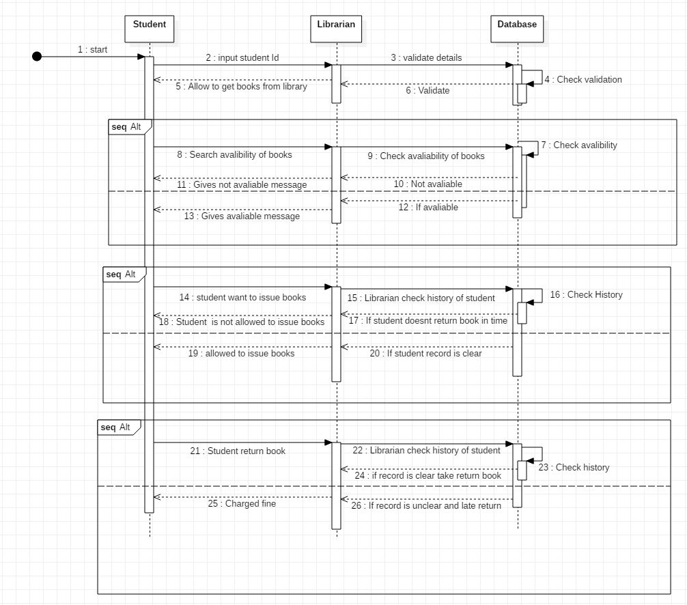

Figure 10 sequence diagram of Student.

### Diagram Explanation

From the above diagram there are three life line student, librarian and database. At first student gives student id to get available books from library. Then, librarian validate card if card is valid then he/she issue books otherwise student can’t get book. Student can able to search availability of books. If student want to take books then librarian check history of student, if student history is bad and student other issue book is still pending then librarian reject it otherwise librarian issue books to student. To return books librarian checks issued and return date if return date is on time, he/she will not be penalized but if return date is already expire then he/she will be charged fine by librarian.

# 3.3 Database Modelling

Database modelling helps to determine the logical structure of a database and basically defines in which way data can be stored and manipulated. Database model is relational model which uses table based format. It shows graphical representation of how data are controlled and shows the relationships among database. Model like data dictionary, ER-diagram and metadata are some of the approach of database modelling.

## 3.3.1 ER Diagram

### Definition

ER diagram also known as entity relationship diagram which is use for database design. The main purpose of using ER diagram is

* It helps to show graphical representation of entities and their relationships to each other.
* It is drawn to understand the requirements of software for which a database is being designed.
* It shows complete logical structure of a database.

### Diagram

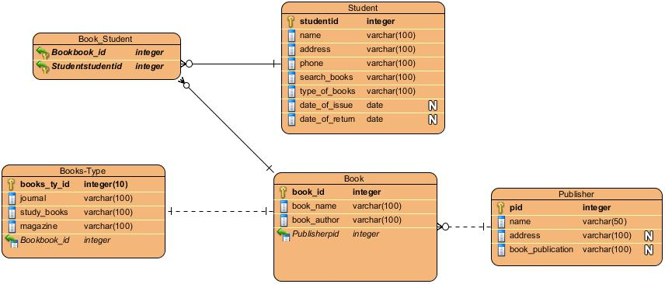

Figure 11 ER Diagram of Library Management System.

## 3.3.2 Data Dictionary

Data dictionary is a file or a set of files that contains a database metadata. It records objects in database, object such as data ownership and data relationships to other object. Data dictionary is important component in rational database. Data dictionary also contain metadata which is data about database.

Below is the metadata of library management system after drawing ER diagram.

**Book**

|  |  |  |  |  |  |
| --- | --- | --- | --- | --- | --- |
| Column Name | Type | Length | Nullable | Key | Constraint |
| book_id | integer | 10 | Not Null | Primary Key | PK_Book |
| book_name | Varchar | 100 | Not Null |  |  |
| book_author | Varchar | 100 | Not Null |  |  |
| Publisherid | integer | 10 | Not Null | Foreign Key | FK_Publisher |

**Student**

|  |  |  |  |  |  |
| --- | --- | --- | --- | --- | --- |
| Column Name | Type | Length | Nullable | Key | Constraint |
| student_id | integer | 10 | Not Null | Primary Key | PK_Student |
| address | Varchar | 100 | Not Null |  |  |
| phone | Varchar | 100 | Not Null |  |  |
| search_books | Varchar | 100 | Not Null |  |  |
| type_of_books | Varchar | 100 | Not Null |  |  |
| date_of_issue | date |  | Null |  |  |
| date_of_return | date |  | Null |  |  |

**Book_Student**

|  |  |  |  |  |  |
| --- | --- | --- | --- | --- | --- |
| Column Name | Type | Length | Nullable | Key | Constraint |
| Bookbook_id | integer | **-** | Not Null | Foreign Key | PK_Book |
| Studentstudentid | integer | **-** | Not Null | Foreign Key | FK_Publisher |

**Publisher**

|  |  |  |  |  |  |
| --- | --- | --- | --- | --- | --- |
| Column Name | Type | Length | Nullable | Key | Constraint |
| pid | integer | - | Not Null | Primary Key | PK_Publisher |
| name | Varchar | 50 | Not Null |  |  |
| address | Varchar | 100 | Null |  |  |
| book_publication | Varchar | 100 | Null |  |  |

**Book-Type**

|  |  |  |  |  |  |
| --- | --- | --- | --- | --- | --- |
| Column Name | Type | Length | Nullable | Key | Constraint |
| books_ty_id | integer | 10 | Not Null | Primary Key | PK_Book-type |
| journal | Varchar | 50 | Not Null |  |  |
| study_books | Varchar | 100 | Not Null |  |  |
| magazine | Varchar | 100 | Not Null |  |  |
| Bookbook_id | integer | - | Not Null |  | FK_Book |

# 3.4 UI (User Interface) Modelling

User interface modelling is a development technique used by computer application programmers. It plays important role in usability of an application. UI helps to design an engaging product and resulting a better understanding of design for everyone involved. It helps to determine the direction of system.

## 3.4.1 Prototyping

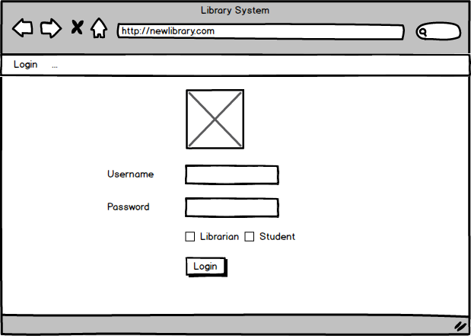

Figure 12 Login form

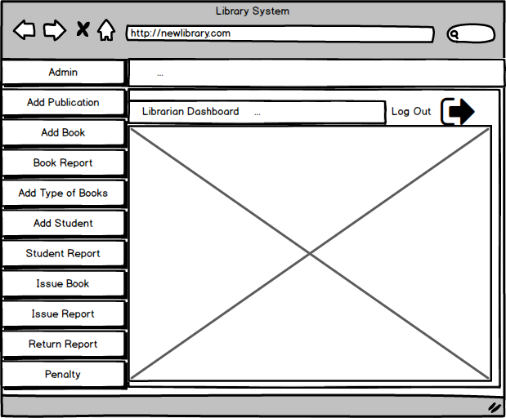

Figure 13 Librarian Dashboard

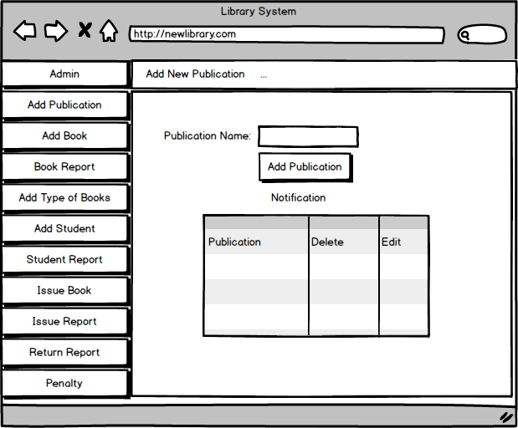

Figure 14 Publication Books Interface.

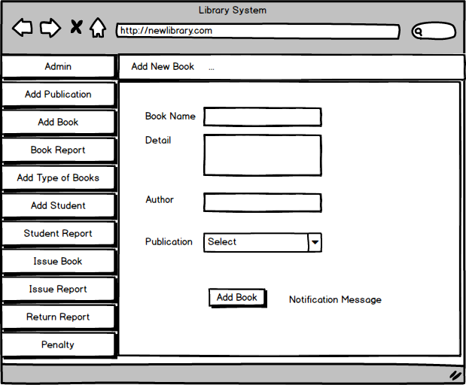

Figure 15 Add Books Interface

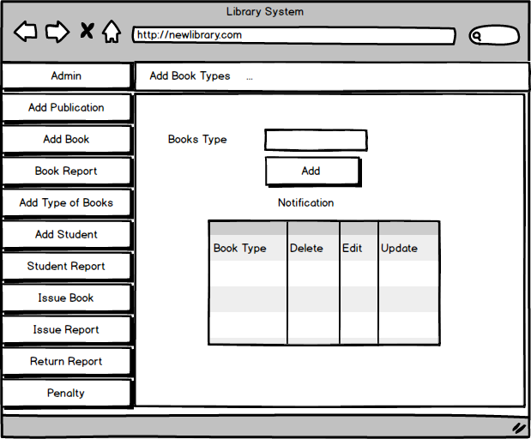

Figure 16 Books Type Interface.

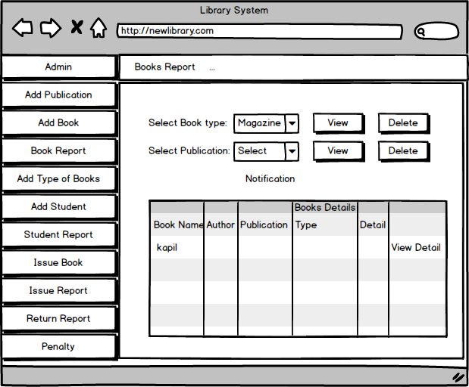

Figure 17 Books report Interface

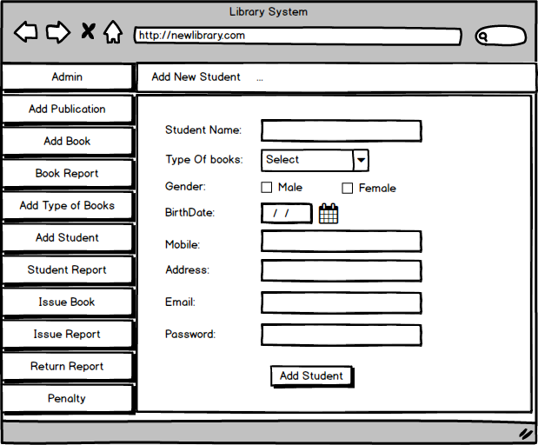

Figure 18 Add Student Interface

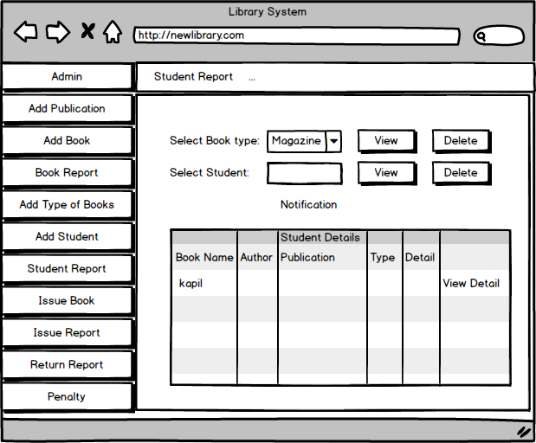

Figure 19 Student Report Interface

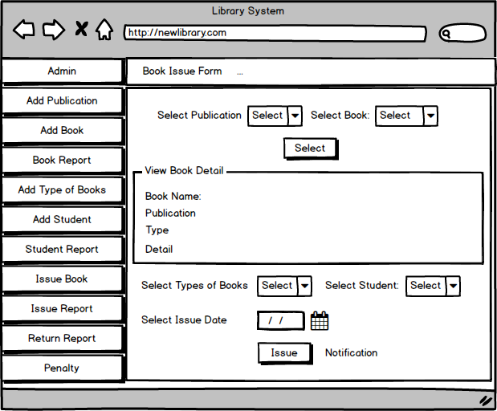

Figure 20 Books Issued Form Interface.

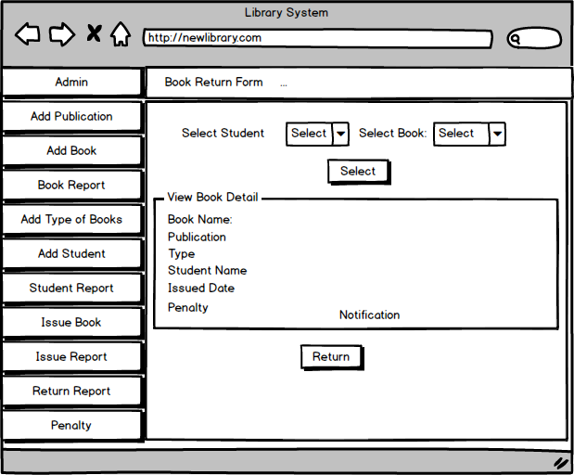

Figure 21 Books Return Form Interface.

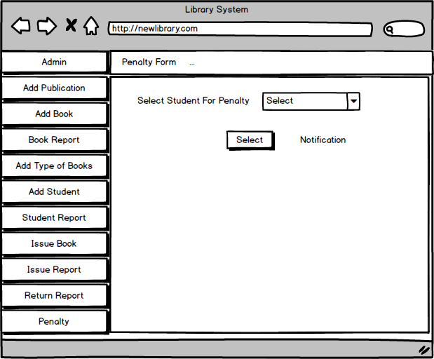

Figure 22 Penalty Form Interface.

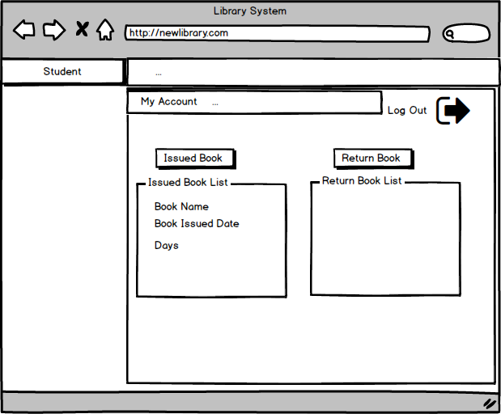

Figure 23 Student Dashboard Interface.

# Chapter 4: Implementation

In implementation process that ideas and policy turn into action in order to achieve the project objectives goals’. In other term it is phase of software development in live environment.

The type of implementation are:

* Pilot installation
* Big bang installation
* Parallel installation
* Web based installation

This develop project is web based installation where it doesn’t require tools and equipment to run.

# Chapter 5 – Testing

Testing is the process of evaluating a system or evaluating its components to find whether it fulfilled the requirements or not. In terms of software testing it is an activity to check whether the actual results match the expected result or not. Software testing is an investigation conducted to provide stakeholders with information about the quality of the software product or service.

Among different testing method I have chosen for black box testing and white box testing

## White box testing

In white box testing it focuses on verifying the flow of inputs and outputs through the application. Mainly, white box testing is based on the inner workings of an application and resolves around internal testing.

### Unit testing

Unit testing is a level of software testing where individual components of software are tested. This type of testing is done to authenticate that separate units of source code is working properly or not.

## Black box testing

In black box testing we just focus on inputs and outputs of the software system without knowing about internal knowledge of the software. In other words, it is type of testing in which it examines the functionality of the software without seeing software internal structure.

## Black Box testing:

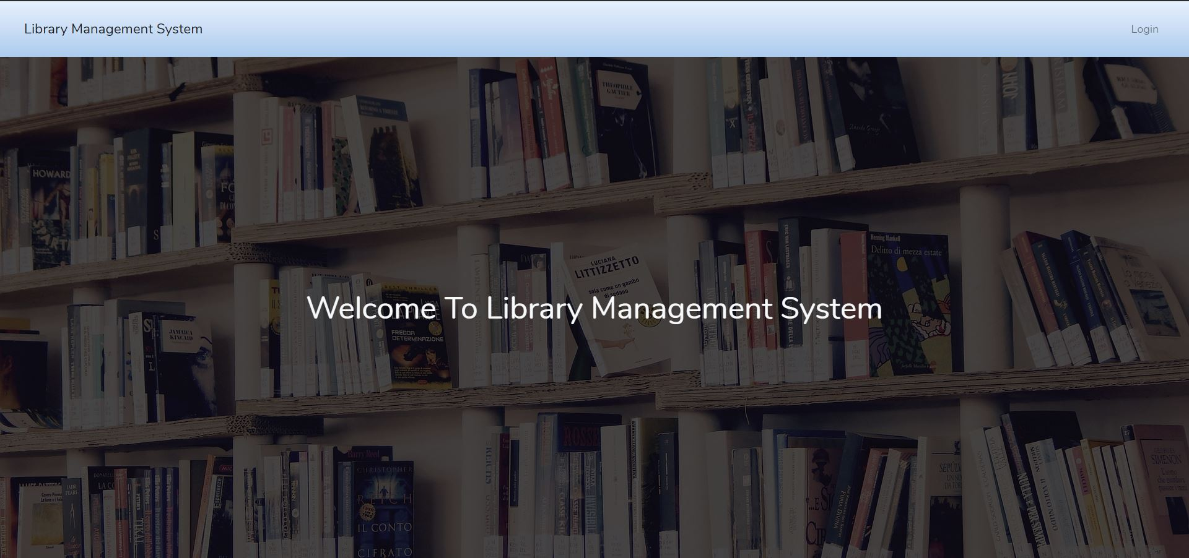

Figure welcome page of library management system

Admin Login form

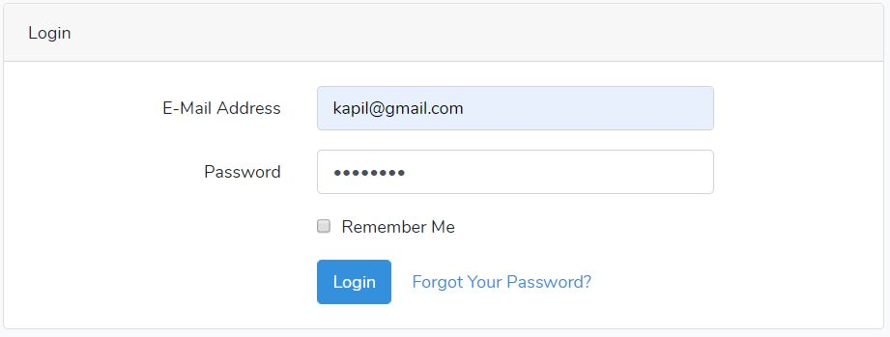

Figure Login form.

After successfully login, admin dashboard is open.

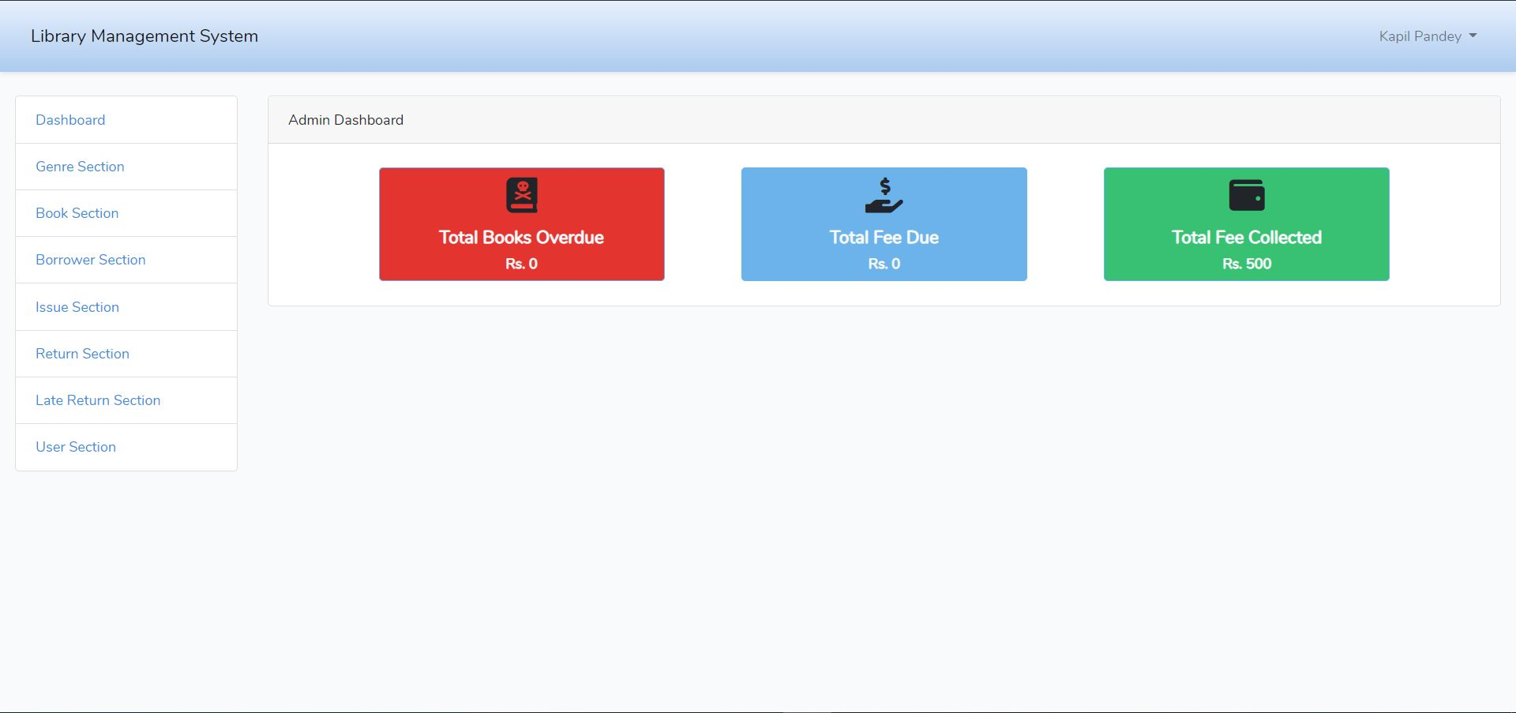

Figure admin dashboard.

Admin update form:

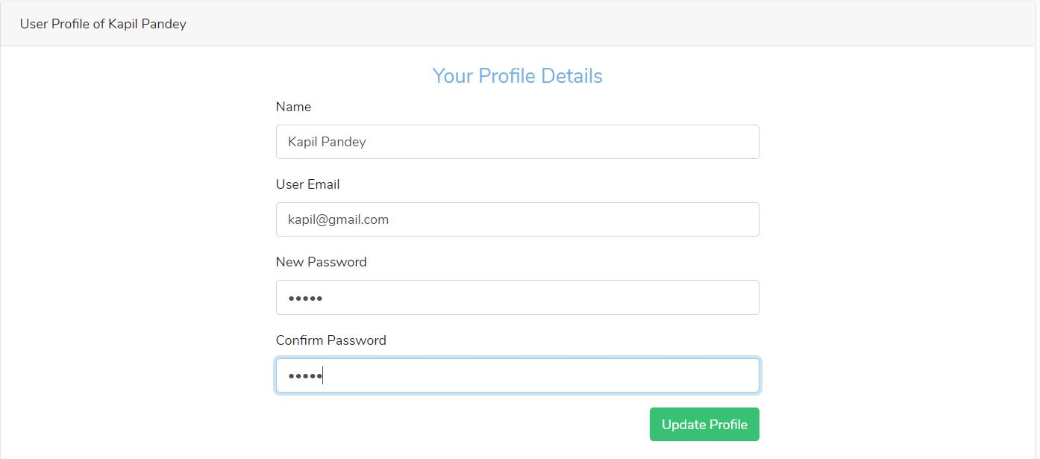

Figure admin update form.

After clicking on update form:

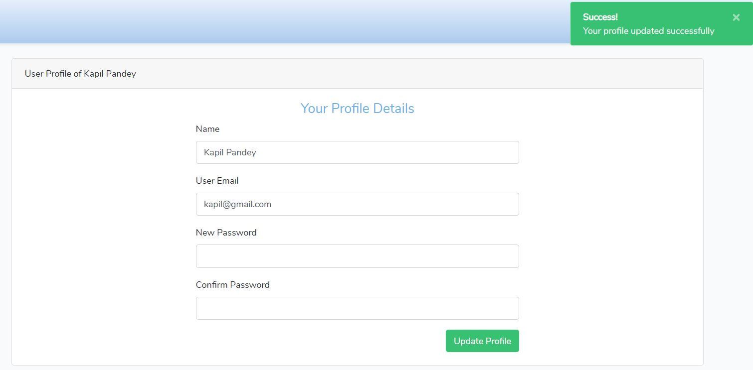

Figure message to display updated profile.

Add genre

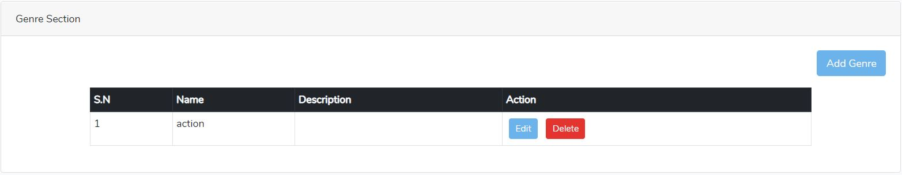

Figure genre or category of book.

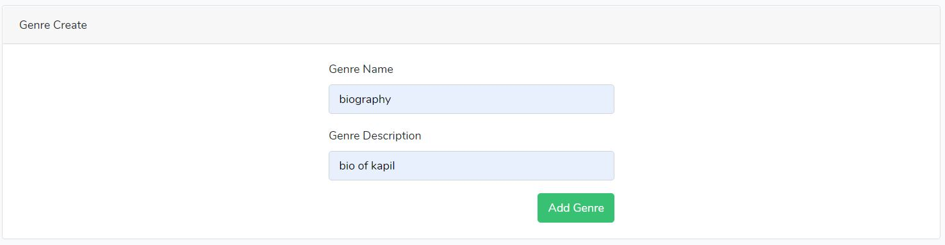

Figure adding category of book.

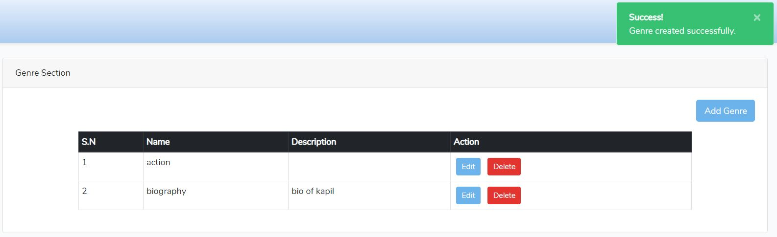

Figure successful adding of genre.

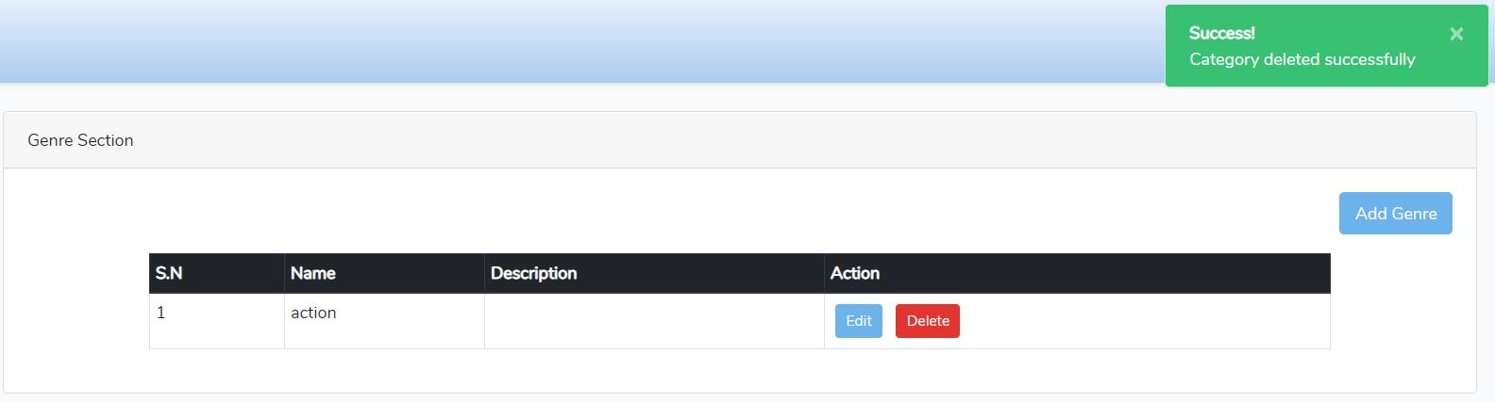

Figure delete message of category.

Add book details

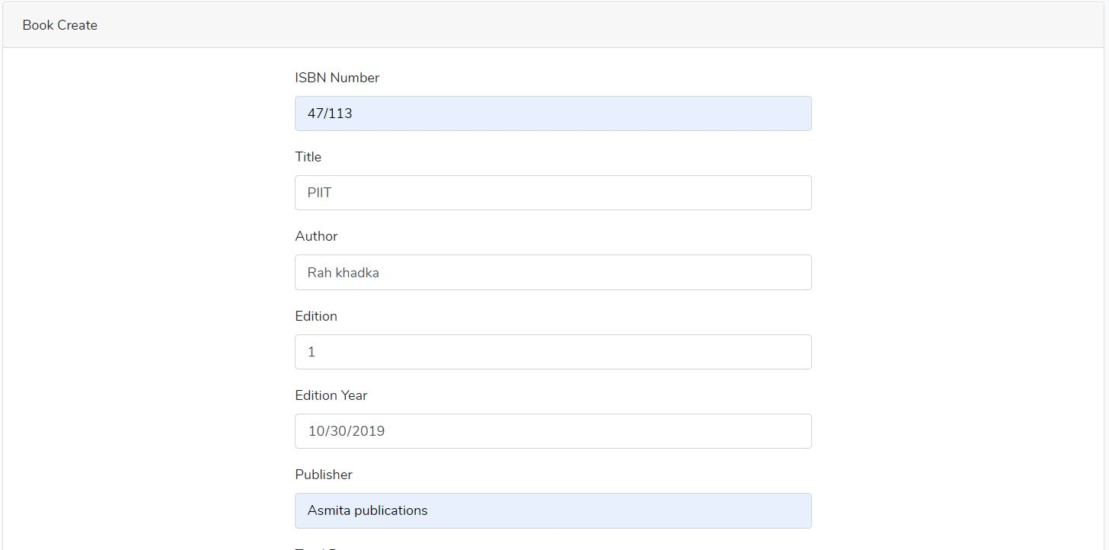

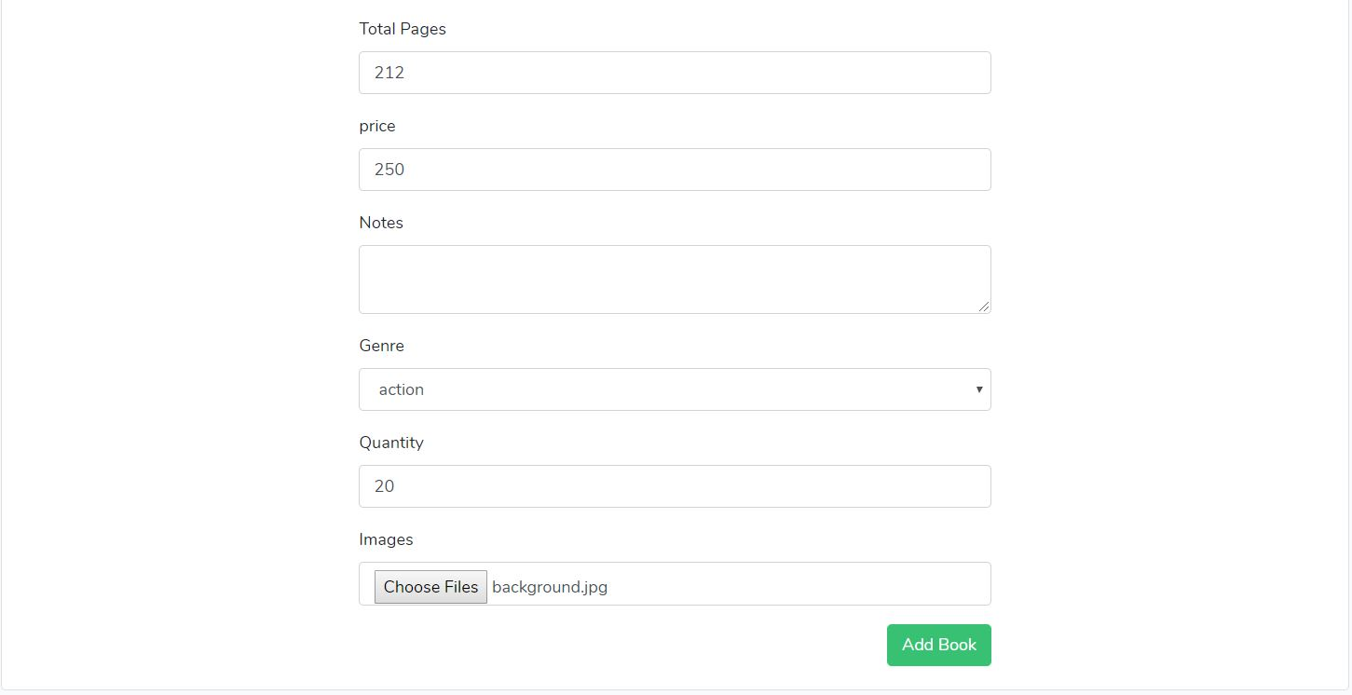

Figure inserting book detail.

After adding book, it perform functionality to delete, update and view the book details

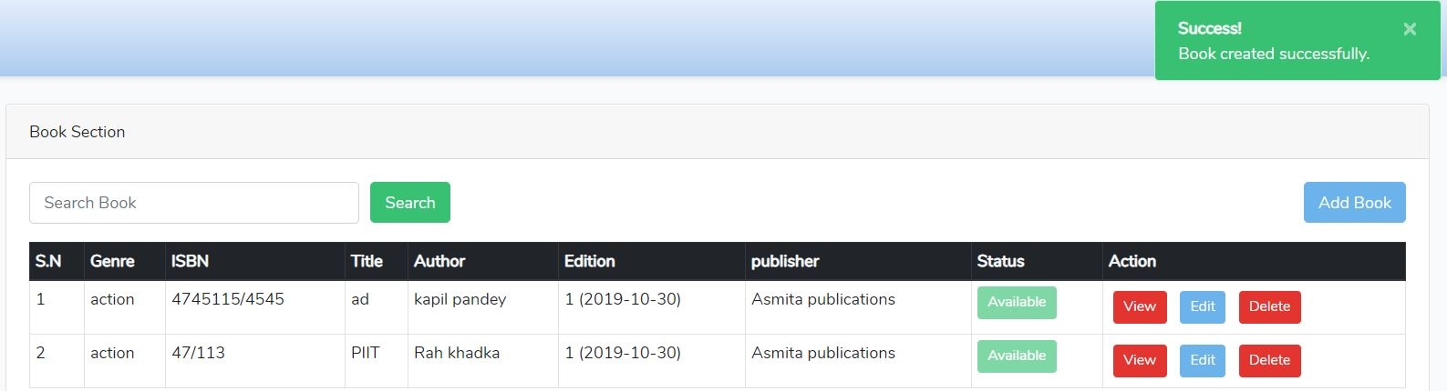

Figure successful message for book insertion.

Search book according to title and check the availability of code.

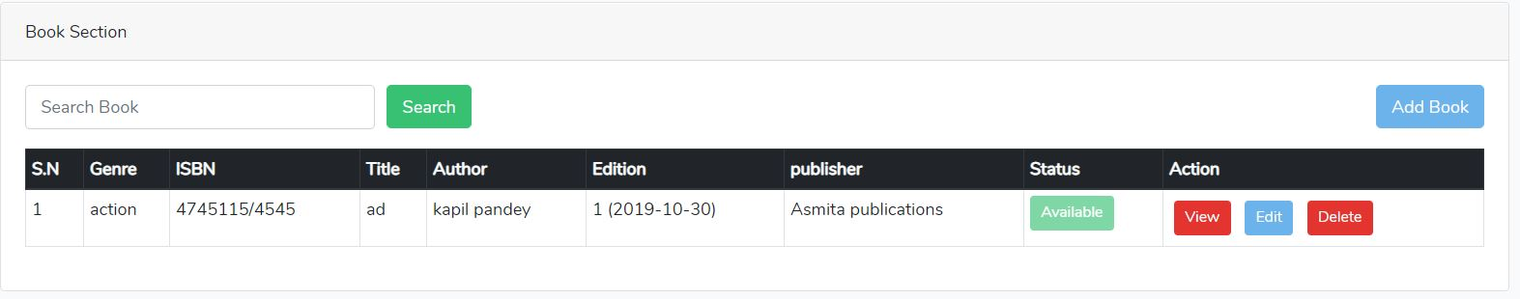

Figure search book section.

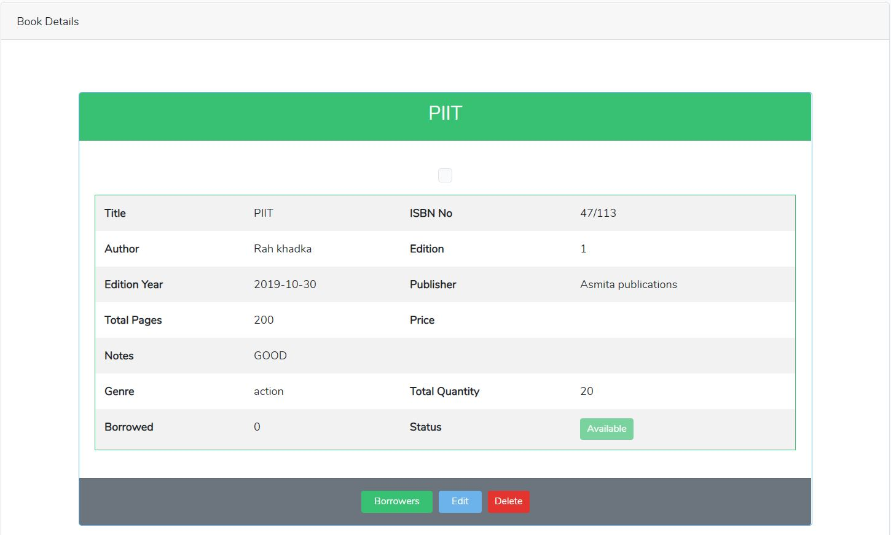

Figure view the book details

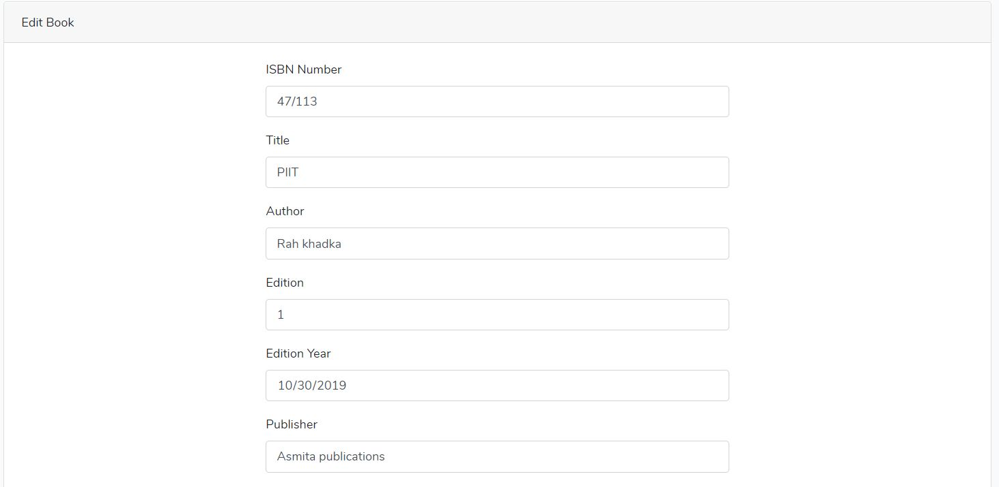

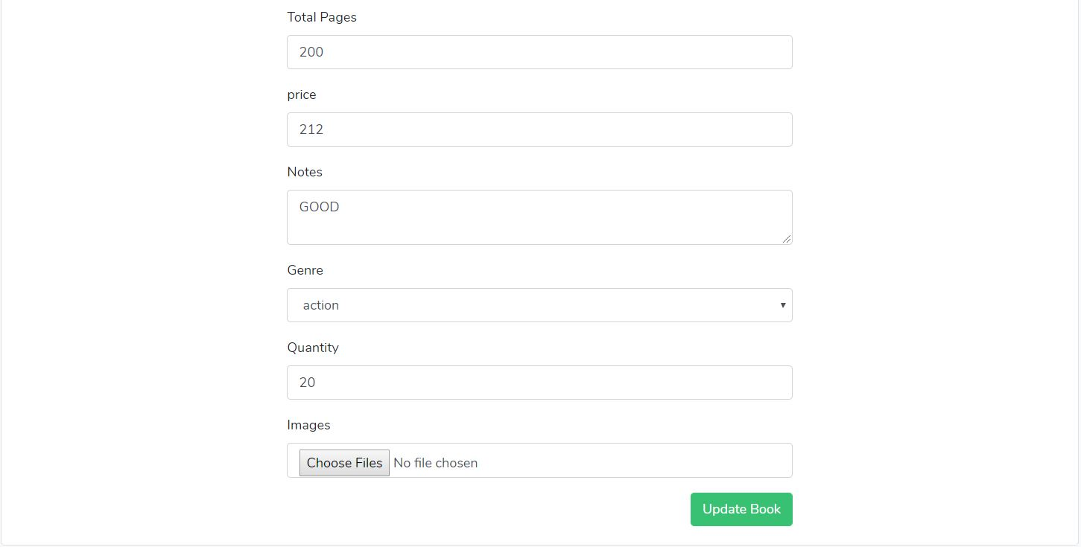

Figure edit book details.

After updating book detail.

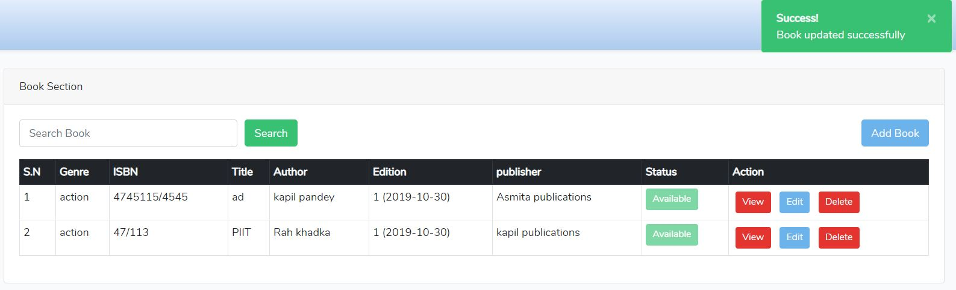

Figure successful message display after updating books.

Book delete successfully.

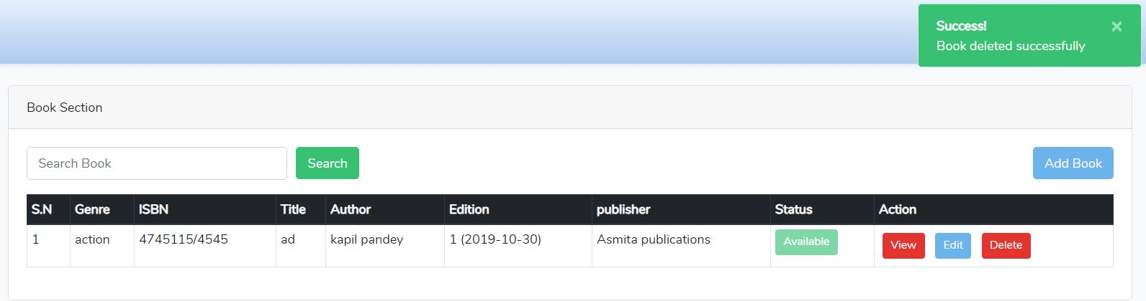

Figure display book delete message.

Borrower section

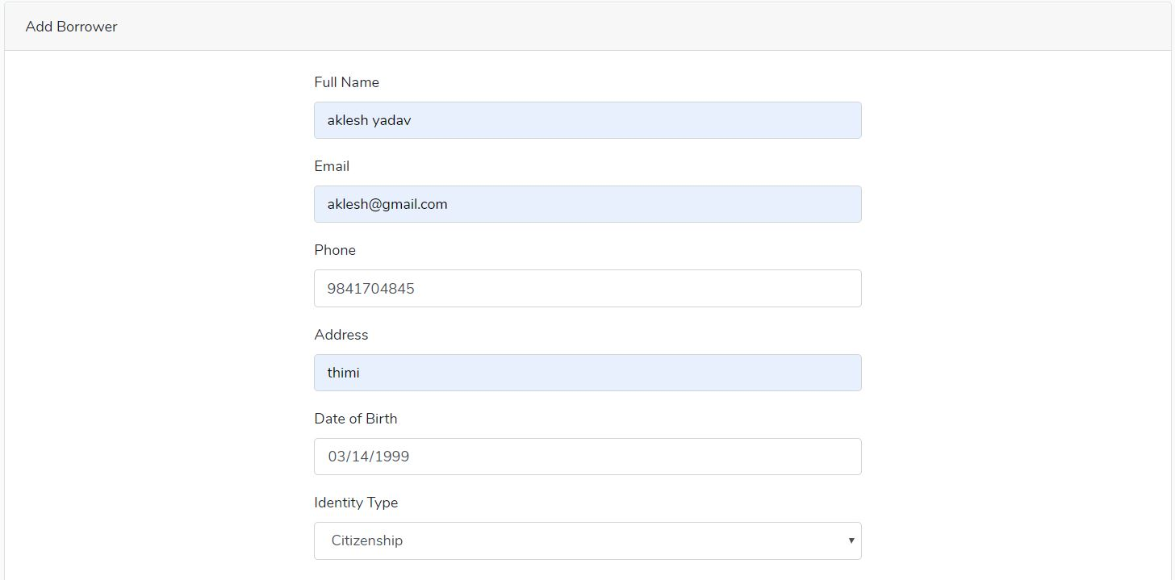

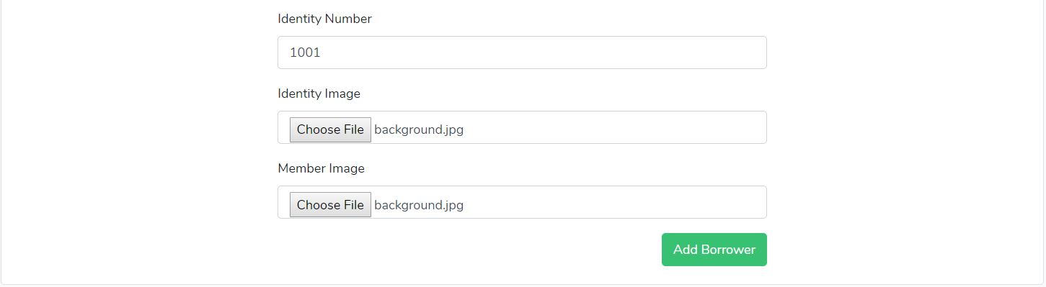

Figure add borrower detail.

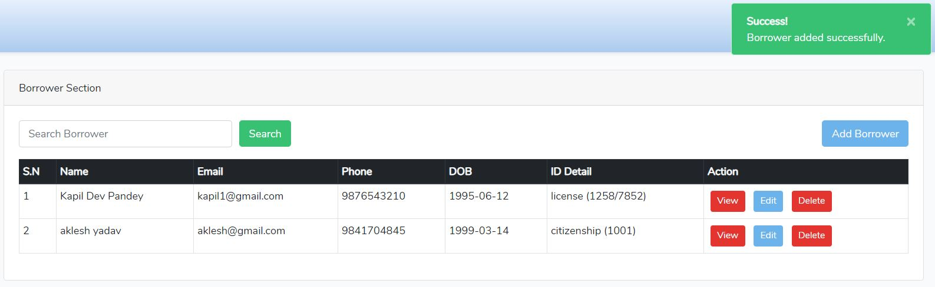

Figure successfully added borrower details.

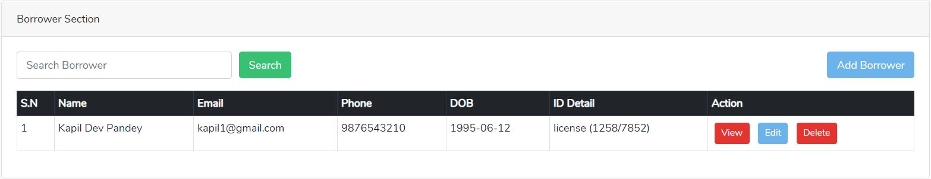

Figure search functionality in borrower section.

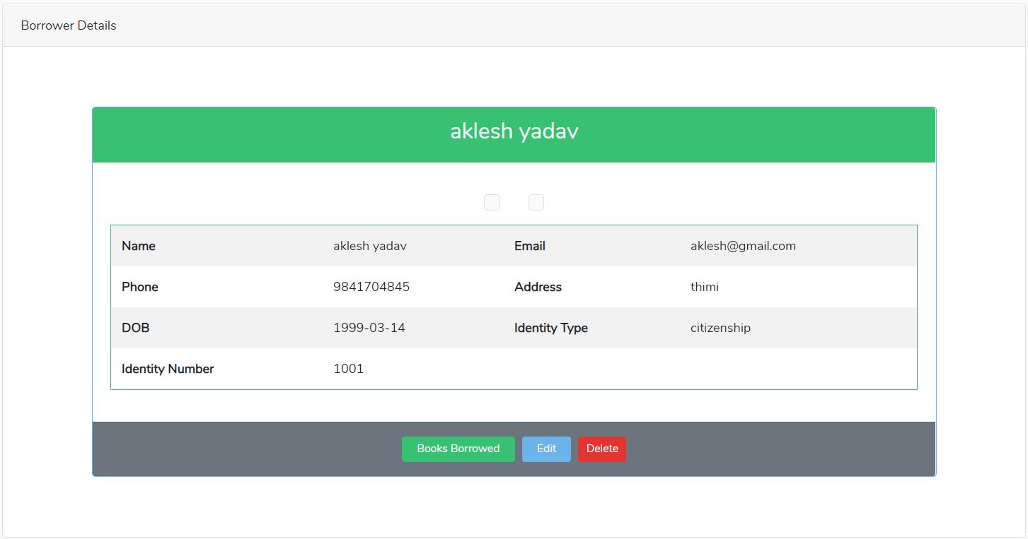Figure can view the borrower details.



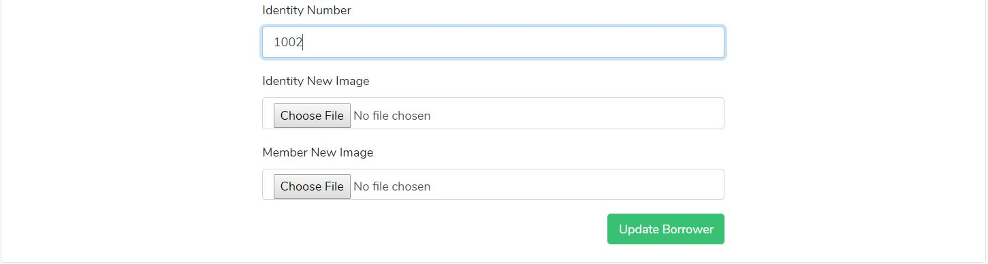

Figure update borrower section.

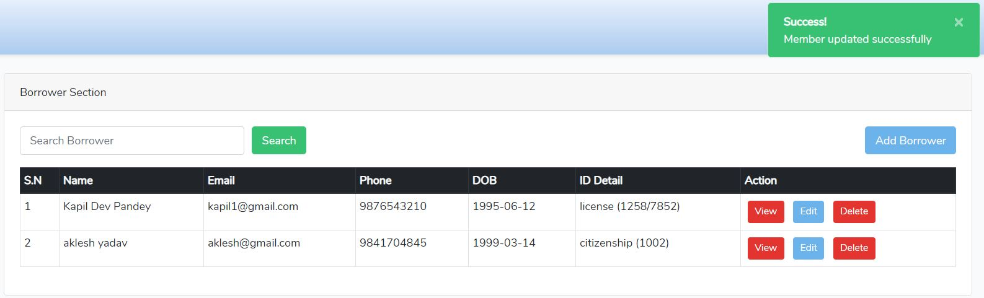

Figure borrower member is updated successfully.

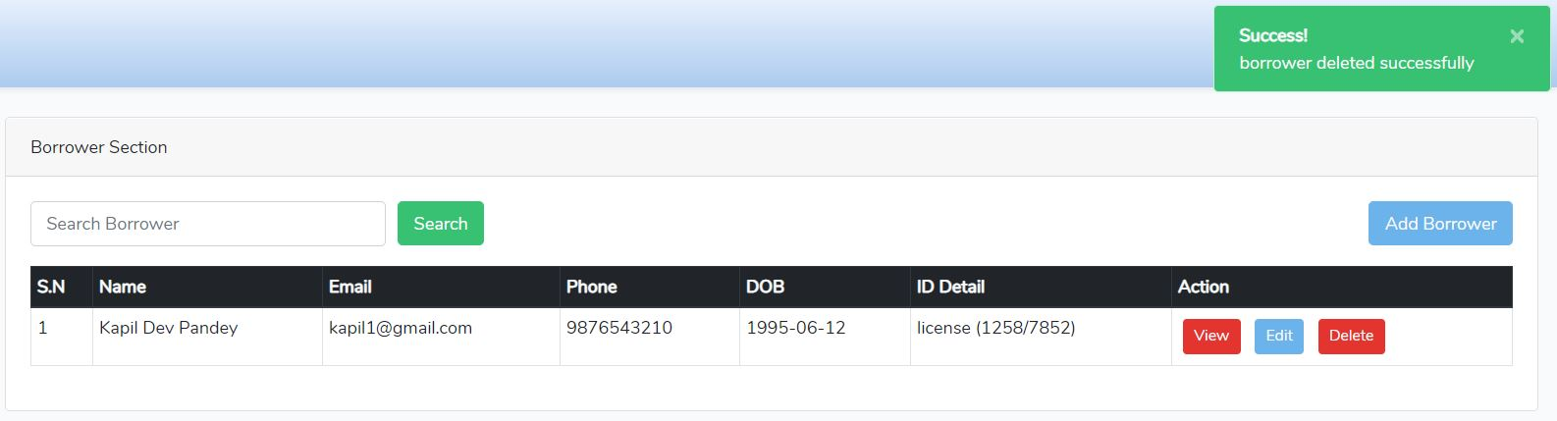

Figure successfully deleted borrower detail.

Issue section

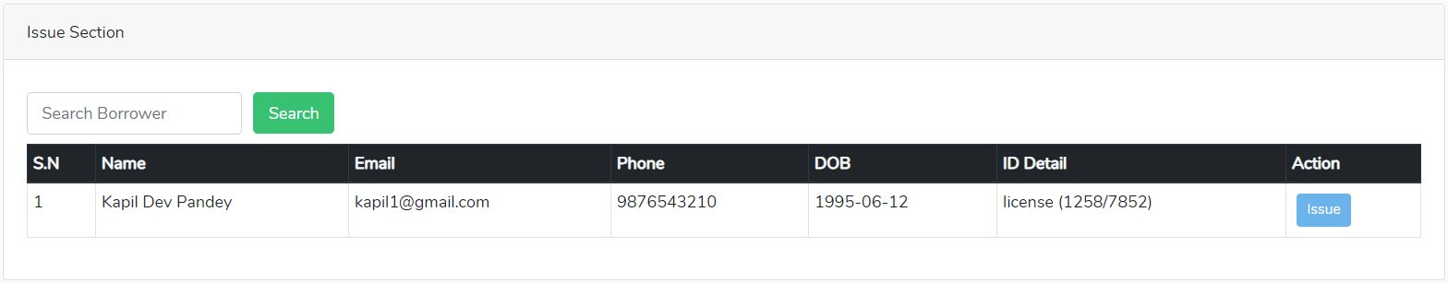

Figure issue section for book.

Search books for issue.

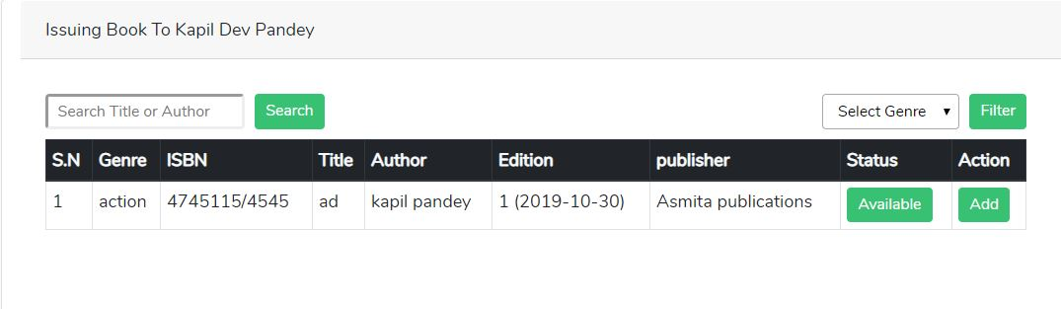

Figure search whom to issue book.

After clicking add button to issue book

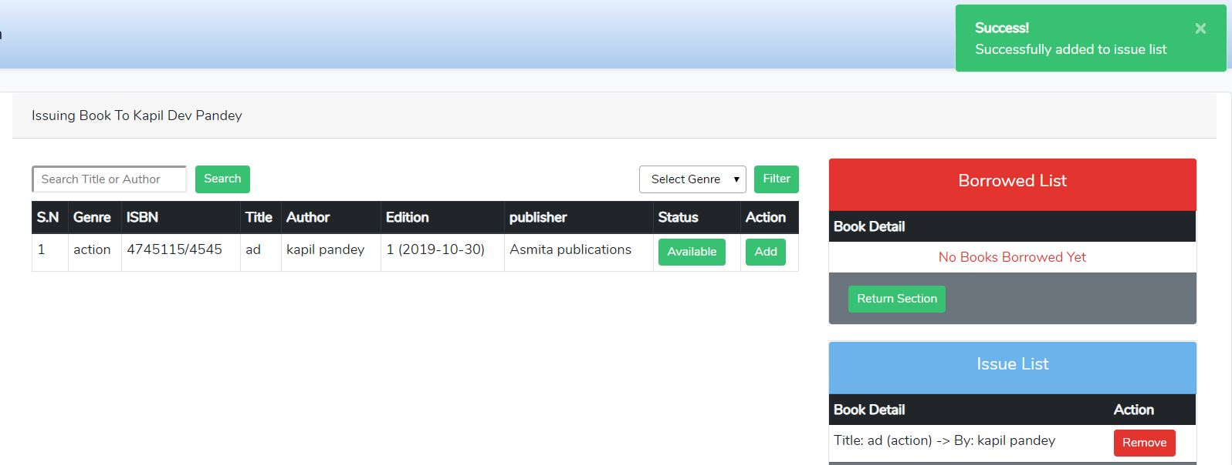

Figure successfully adding issue list details.

After successfully issued of books then books moved to borrower list book details.

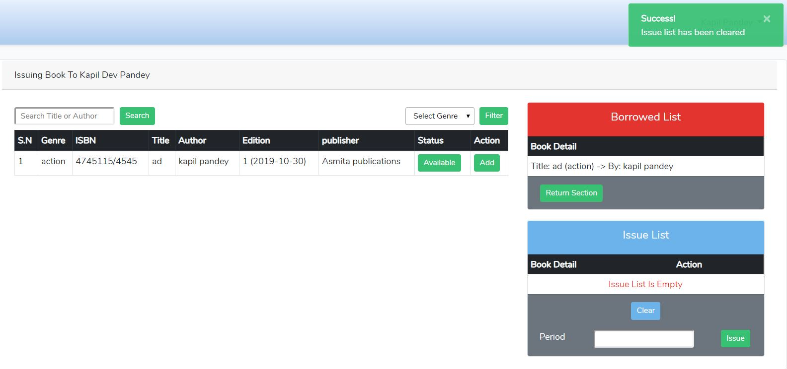

Figure issued list has been cleared and move to borrowed list.

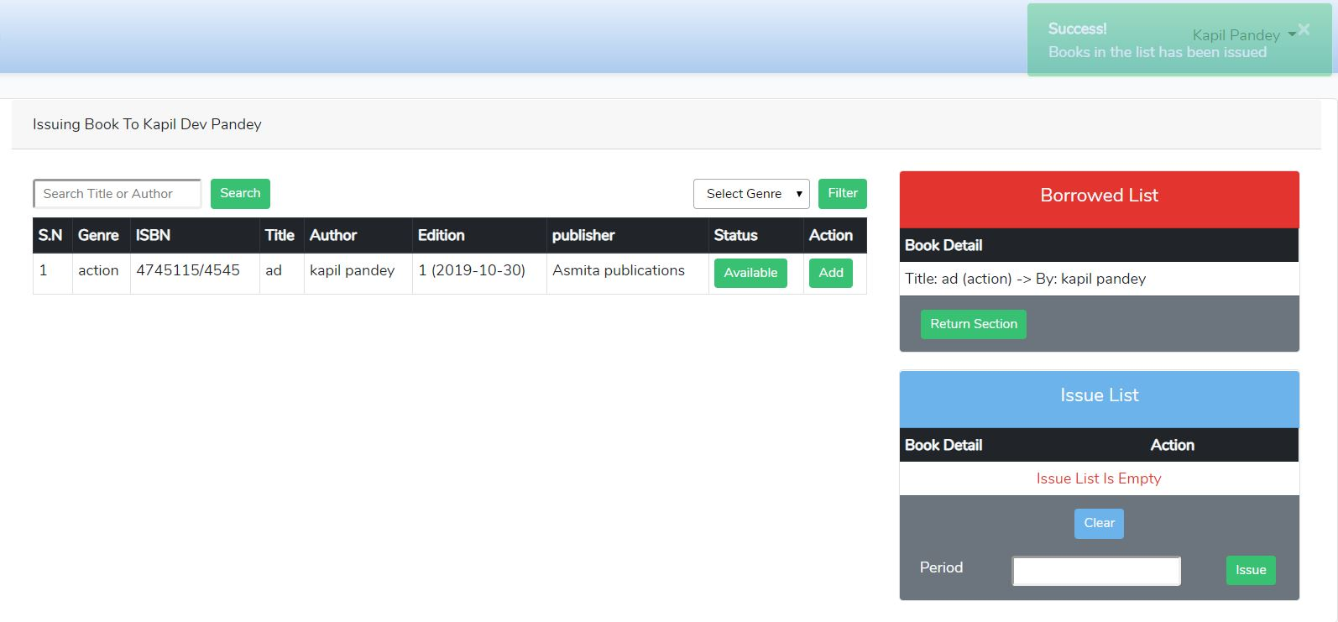

Figure books in the list have been issued,

Return section

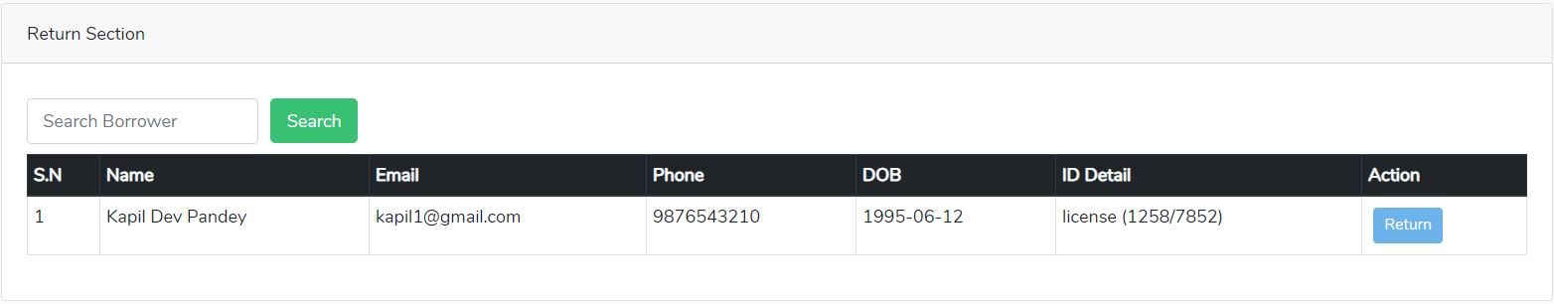

Figure book return section.

After clicking return button

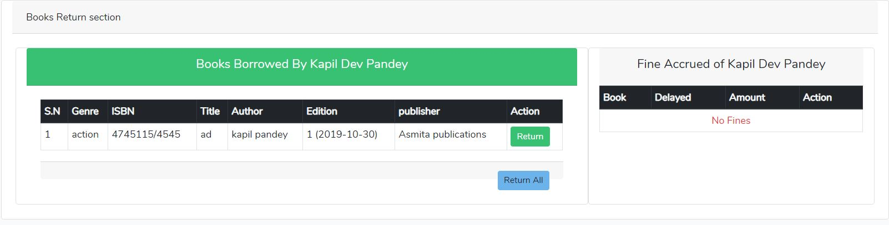

Figure return book if there is no fine.

If there is fine for borrower then, borrower can’t return book until and unless they pay fine.

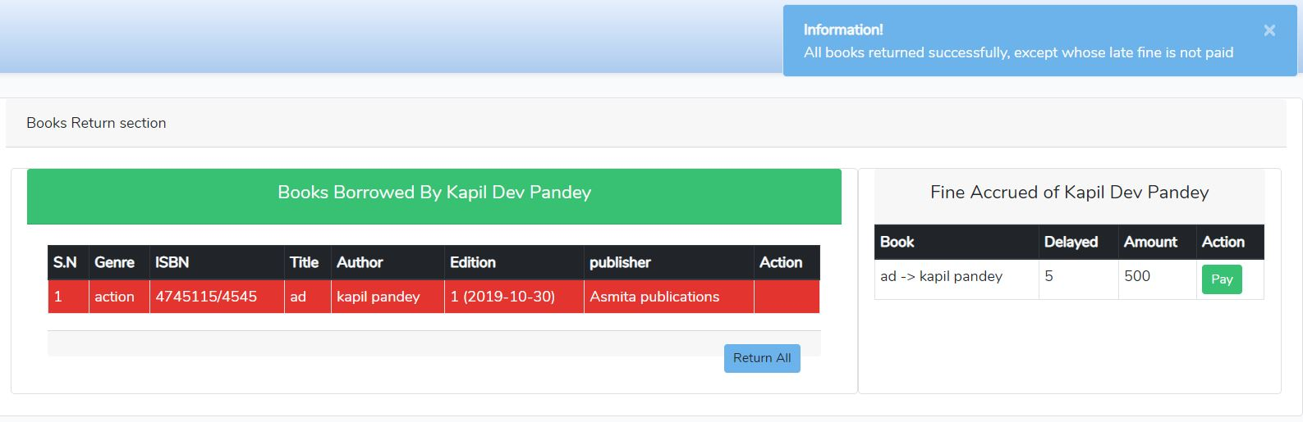

Figure if books that have fine then it avoids to return books.

Payment of fine by borrower.

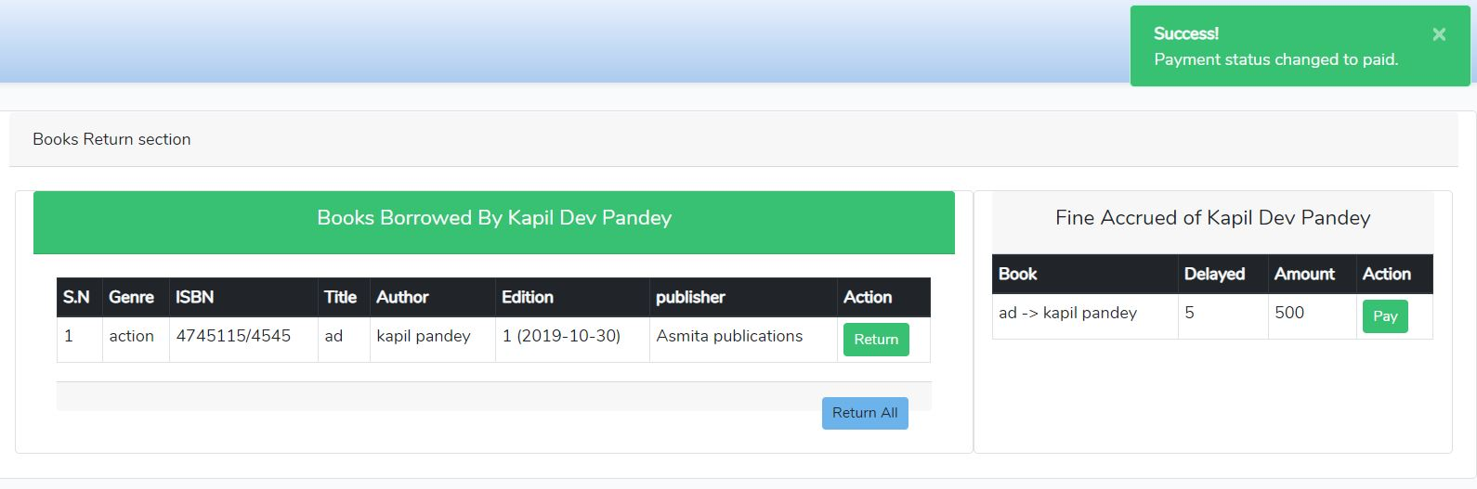

Figure successful payment for fine notification

After payment is successfully paid then borrower can return book.

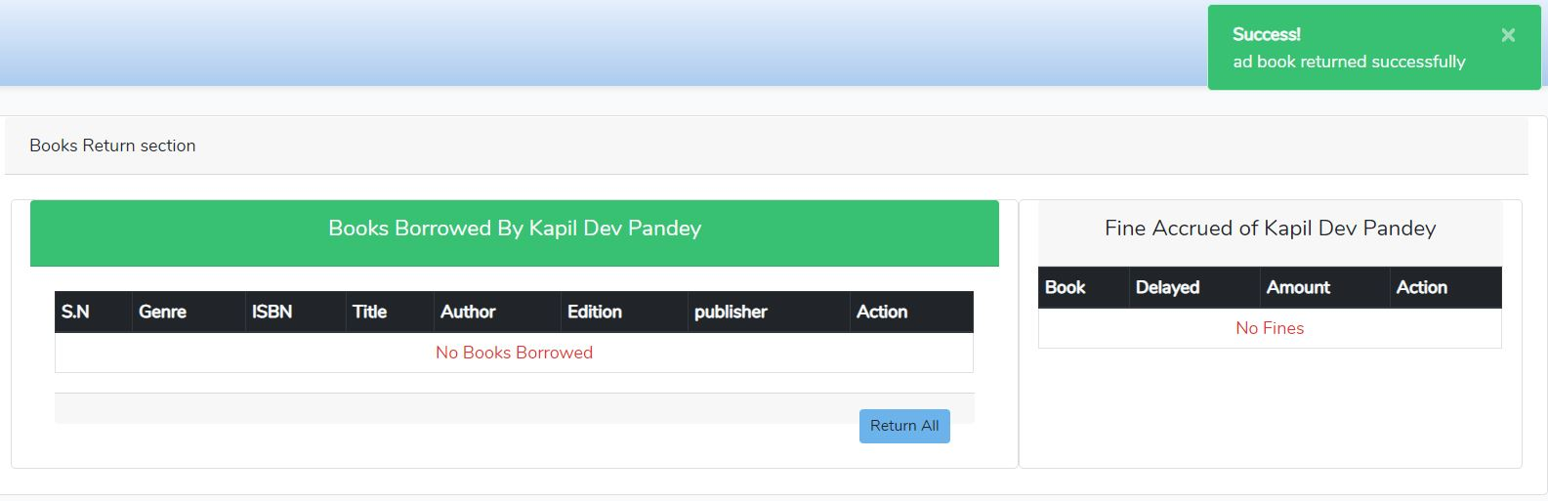

Figure successfully return of issued books.

Late return section

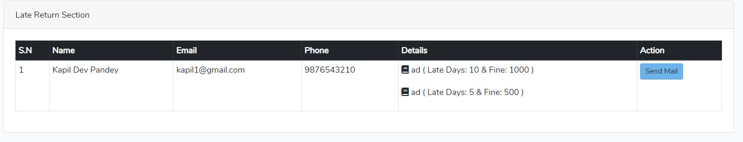

Figure late return section.

After clicking mail section then borrower will send mail to pay fine.

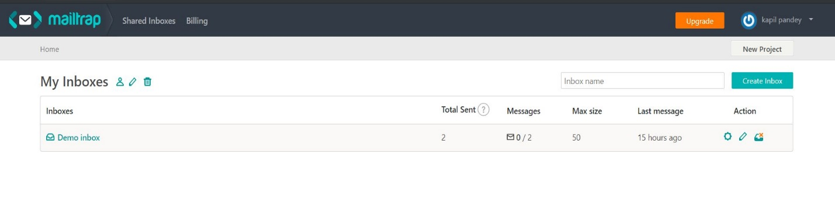

Figure fine message send to mail.

Fine payment mail will be sent to mailtrap.io

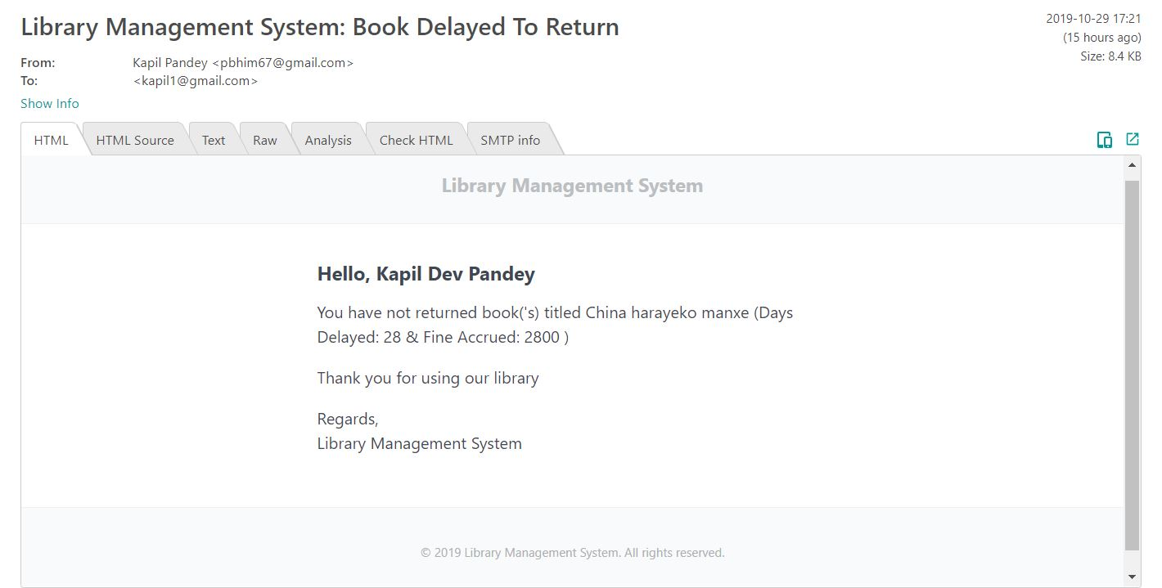

Figure book delayed message sent to mail.

Book delayed message.

User/Admin Section

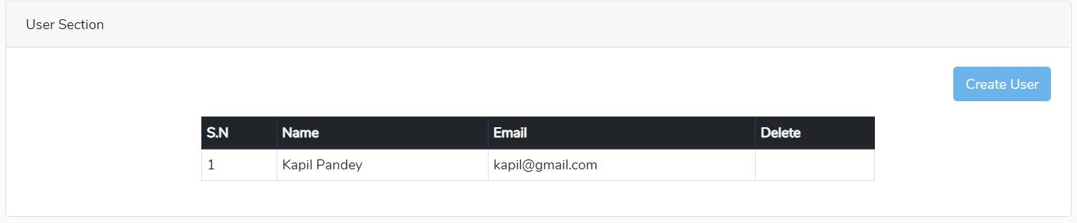

Figure admin profile

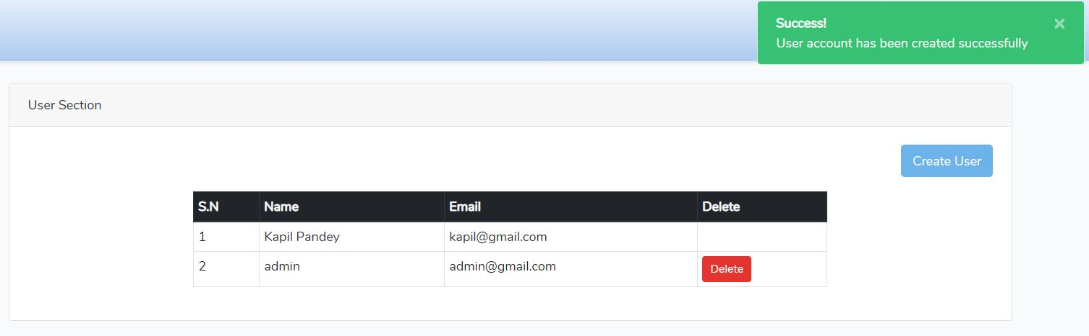

Figure admin account has been created successfully.

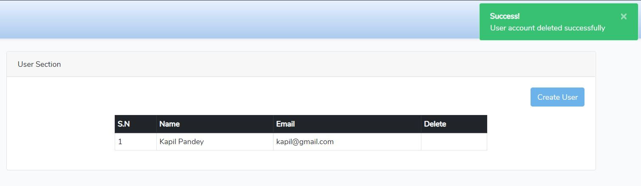

Figure admin account deleted successfully.

# Chapter 6 - Other Project Issue

## 6.1 Limitation

Some of the limitation of Library Management System are:

* System is not suitable for online booking or purchase of book.
* Software is suitable for small and medium scale library.
* User interface (UI) need to be improved.
* Entire data will be collapsed if software is corrupted.

## 6.2 Future Work

While designing system there are some feature that are excluded. So those feature are added to complete in future.

* Forget password confirmation.
* Student can’t delete their profile.
* Need to develop online booking or purchase of work.
* Need to develop user friendly interface for easy use of the system.

## 6.3 Risk Management

It is the procedure used by job managers to reduce any possible difficulties that may undesirably influence a project's schedule. Risk is any unpredicted occurrence that might distress the persons, procedures, technology, and resources involved in a project.

Risk management includes the following tasks:

* To recognize risks with their respective causes.
* Categorize and arrange the all possible risk.

From the above risk listed in proposal, the risk which I face is memory crash, insufficient feature and insufficient time to complete the project. So, due to arise of above risk I tend to fail to add additional feature like student update profile.

## 6.4 Configuration Management

Configuration management is a system manufacturing procedure for starting and preserving reliability of a creation's act, practical, and bodily attributes with its requirements, design, and operative information during its lifecycle.

The following reason for using software configuration management

* Changes in requirement of the project.
* Needs to change the project schedule.
* Due to uncertain change of Government rules and regulation.
* It helps to reduce the redundancy of project.

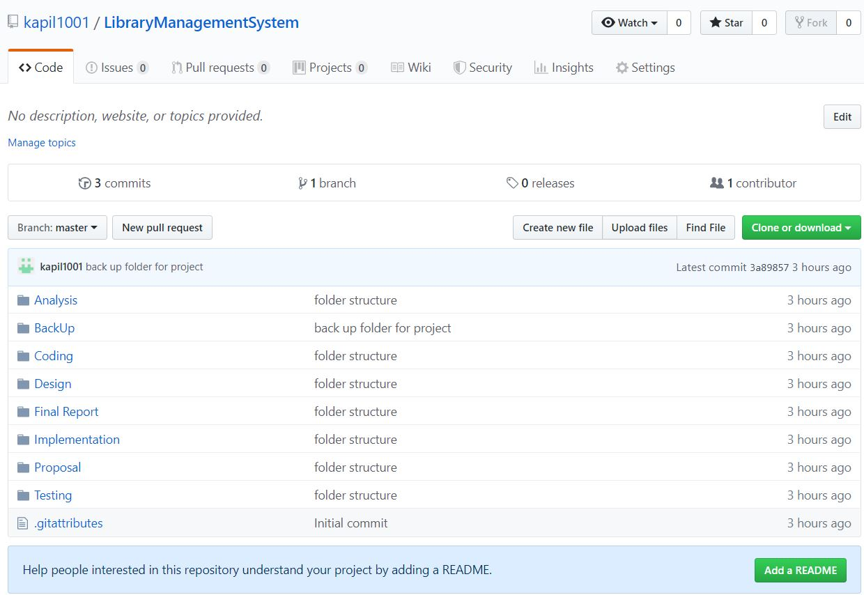

Figure GitHub directory of Library Management System.

For the safety of project I have created a backup folder where there are sub folders (Analysis, design, coding, testing etc.) for describing each stages of the project. As well as I have created GitHub account named kapil1001 for online backup where all folders are stored for future use. The main reason for using GitHub account is code that has been used previously can be reused here which helps to save time for project. Below is the link of GitHub Directory <https://github.com/kapil1001/LibraryManagementSystem>.

As well as, I have created backup in my local PC. Below is the project local backup directory.

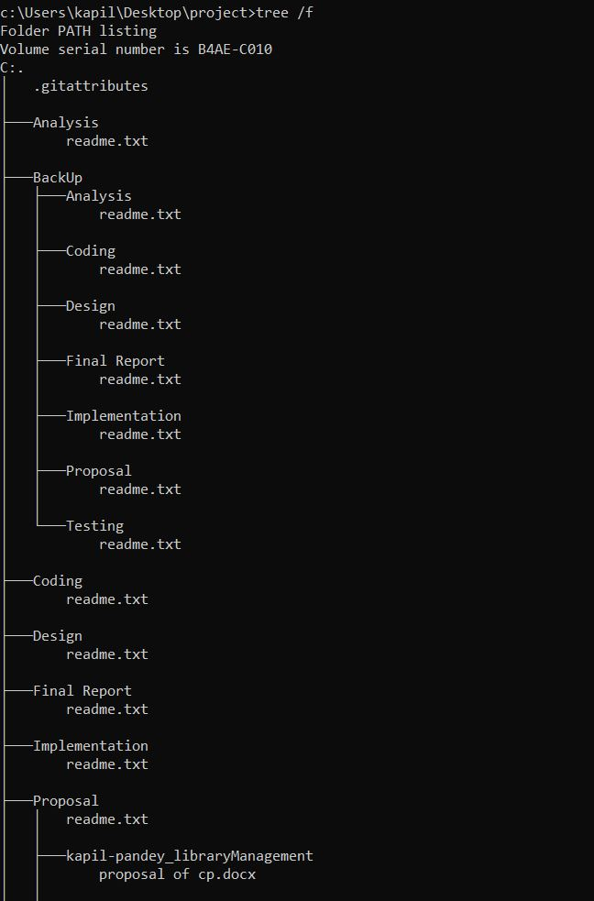

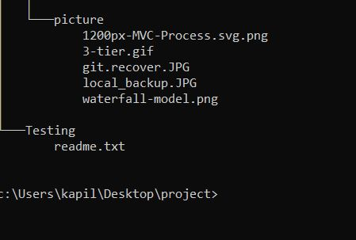

Figure Project Local backup Directory.

## 6.5 Other Project Issue

I don’t face any problem while developing this project because all the tools and software that are used in this project is free of cost and open source.

## 6.6 User Manual

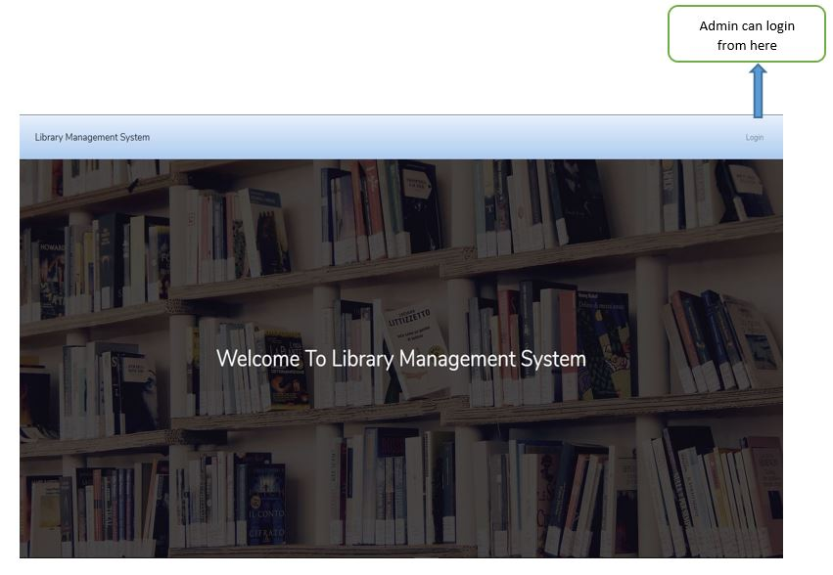

Figure welcome page of library management system.

This is start page where login form open by clicking login button.

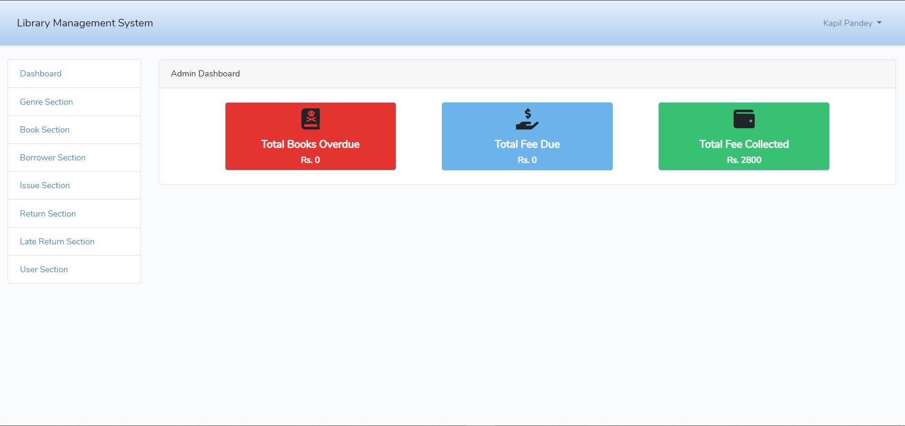

Figure admin dashboard.

After successfully login then it open admin dashboard where admin can add, delete, update and view books and students.

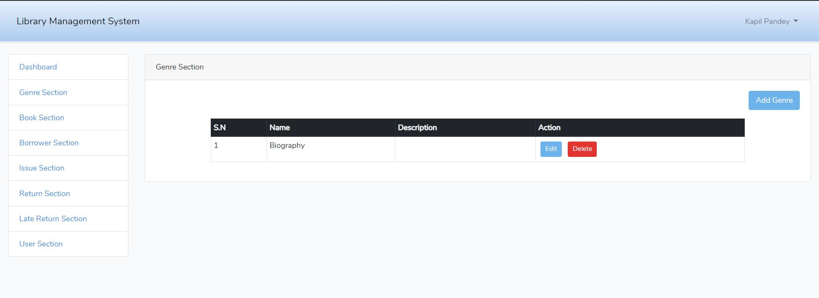

Figure genre section of library system.

In this section admin can add genre and description of books like whether book is biography or action or science fiction. Admin can also edit and delete genre.

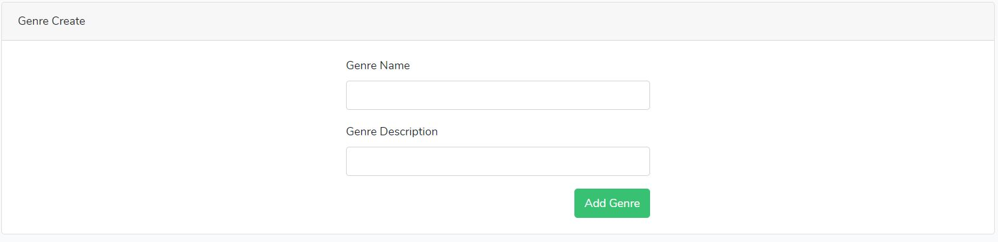

Figure form to create genre.

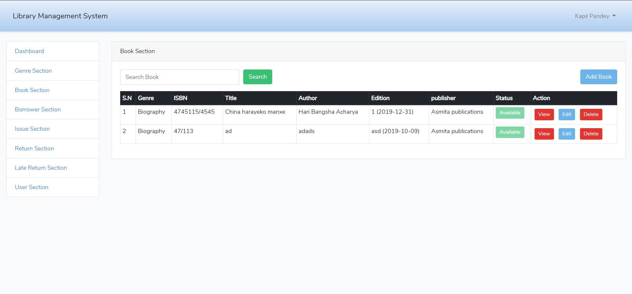

Figure book section.

From this page admin can add the books, search books, check the availability of book, edit, delete and view the books.

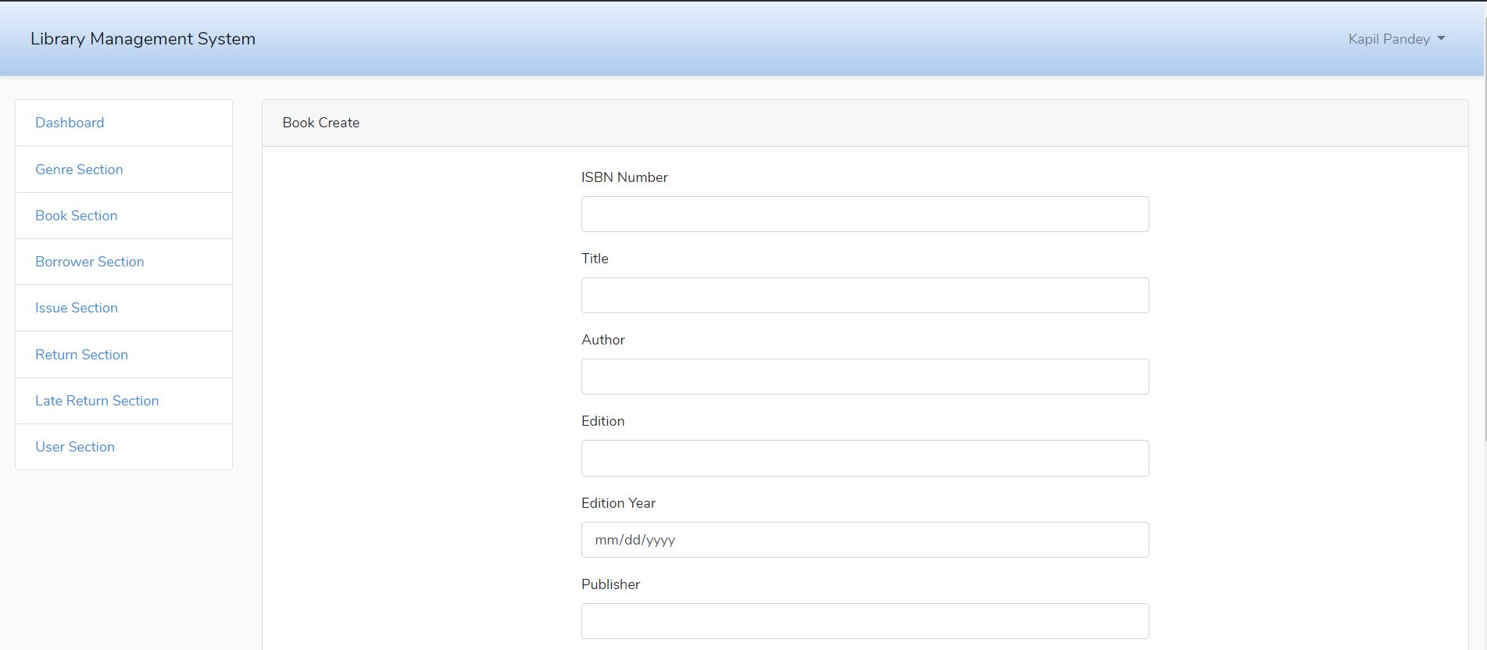

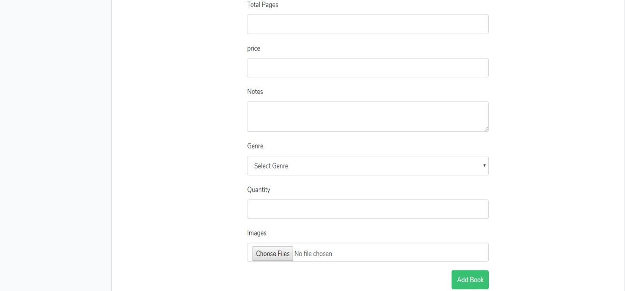

Figure adding new book by admin.

In this form admin can the books detail.

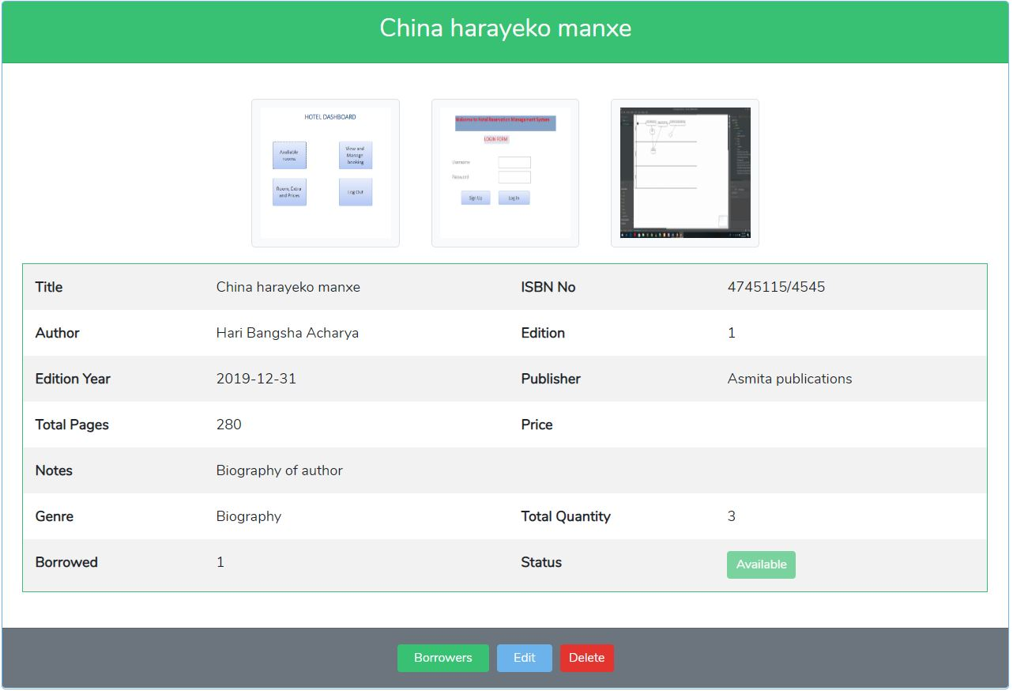

Figure view of books details.

From this page admin can view the books details and can see how many borrowers take this book, as well as he/she can edit or delete books from here

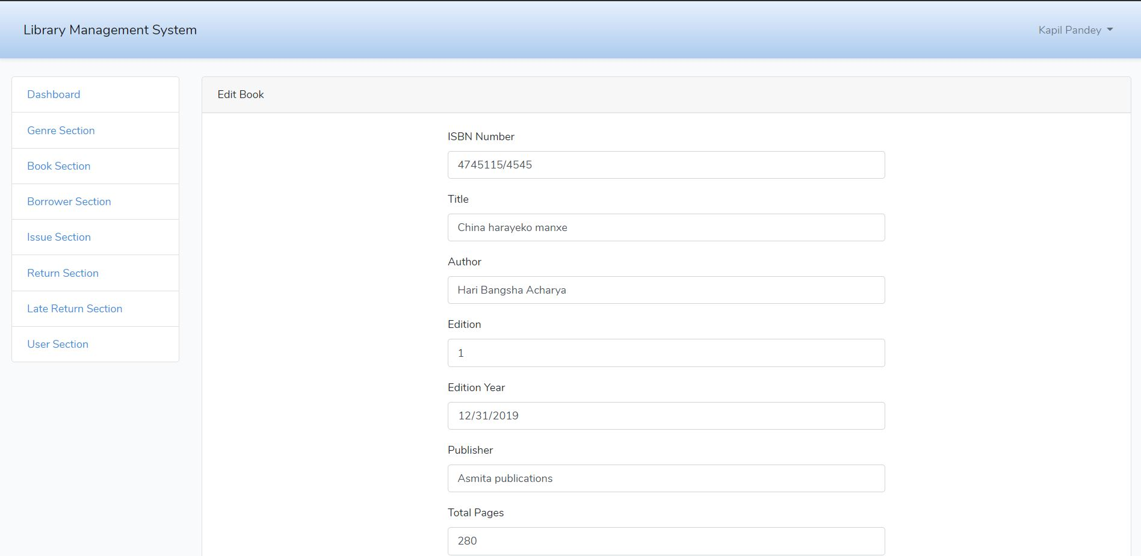

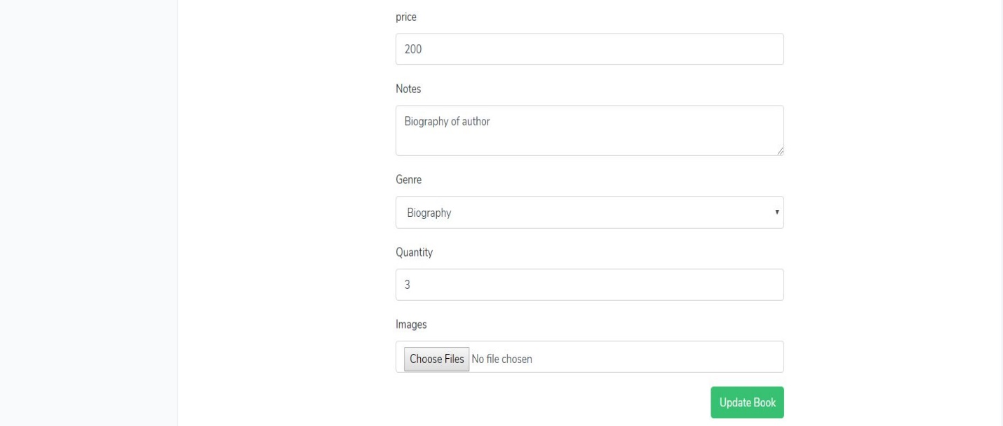

Figure update books details

Admin can update the books details after clicking on update bottom.

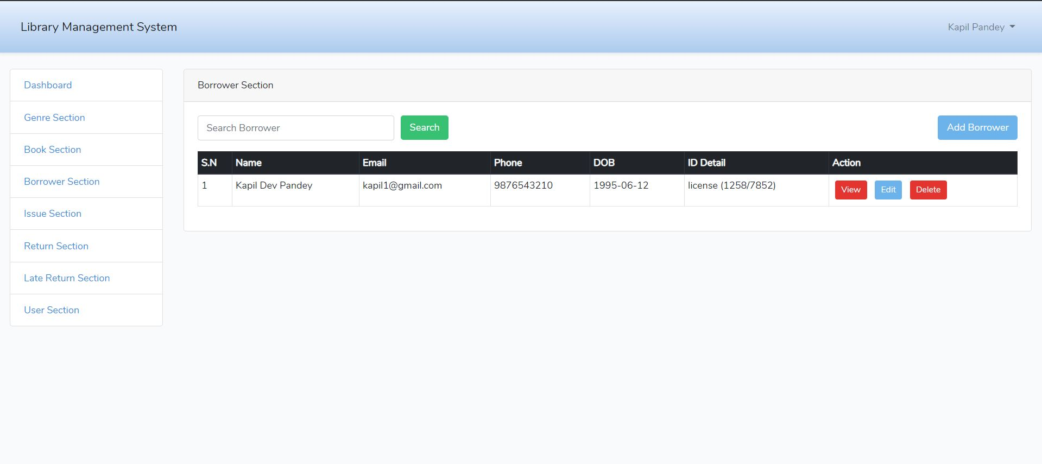

Figure borrower section.

From this page admin can see the list of borrower and can add, view, search, edit and delete the borrower details.

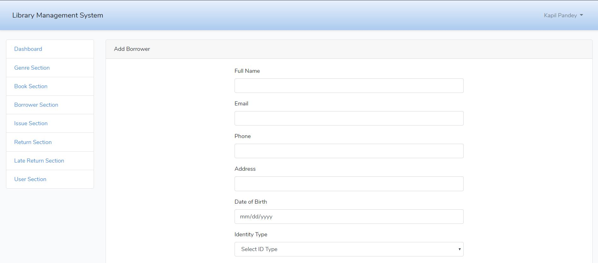

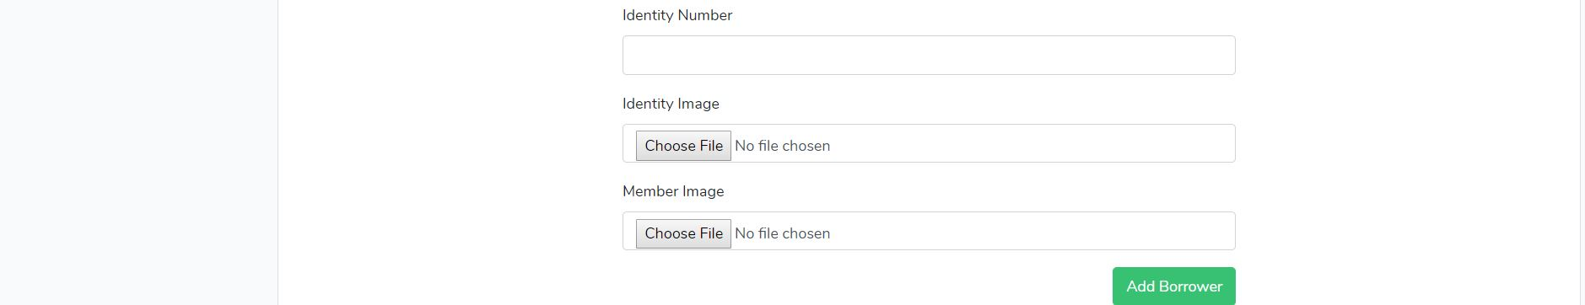

Figure borrower form.

Admin can add the borrower details in this form.

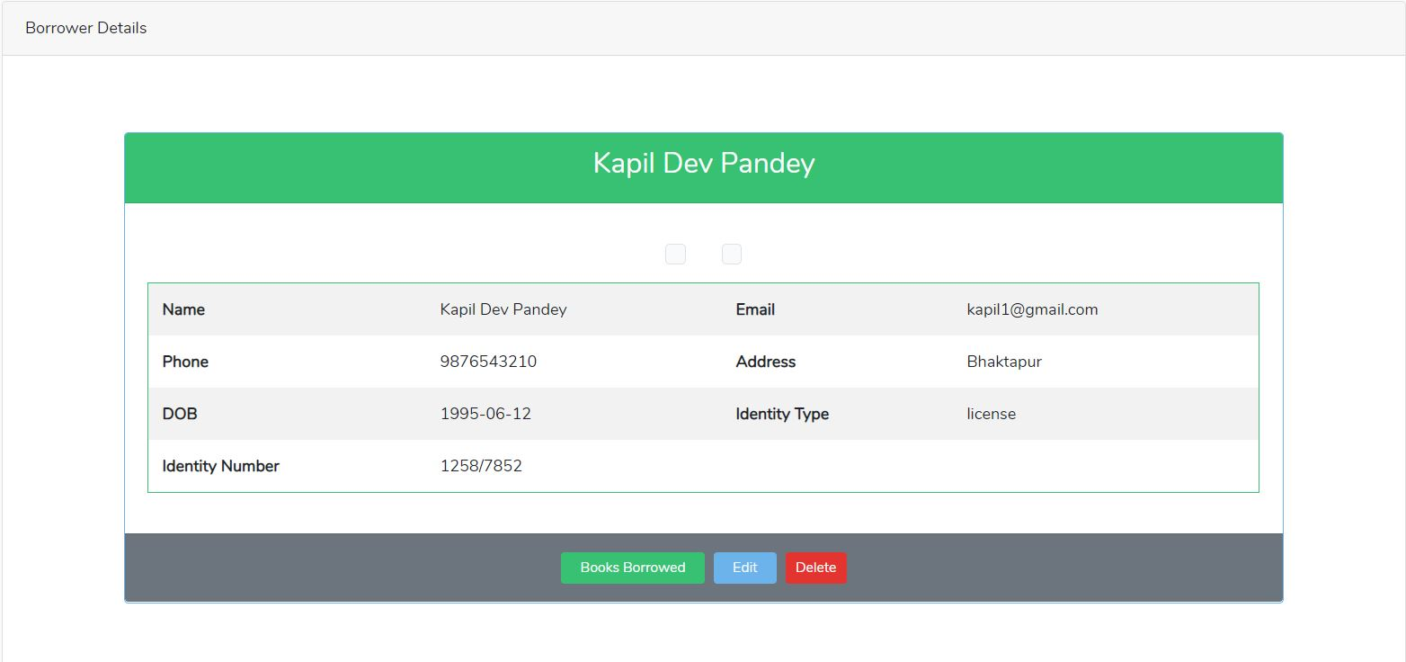

Figure borrower details

Admin can see the student who borrowed the books and can edit and delete borrowers.

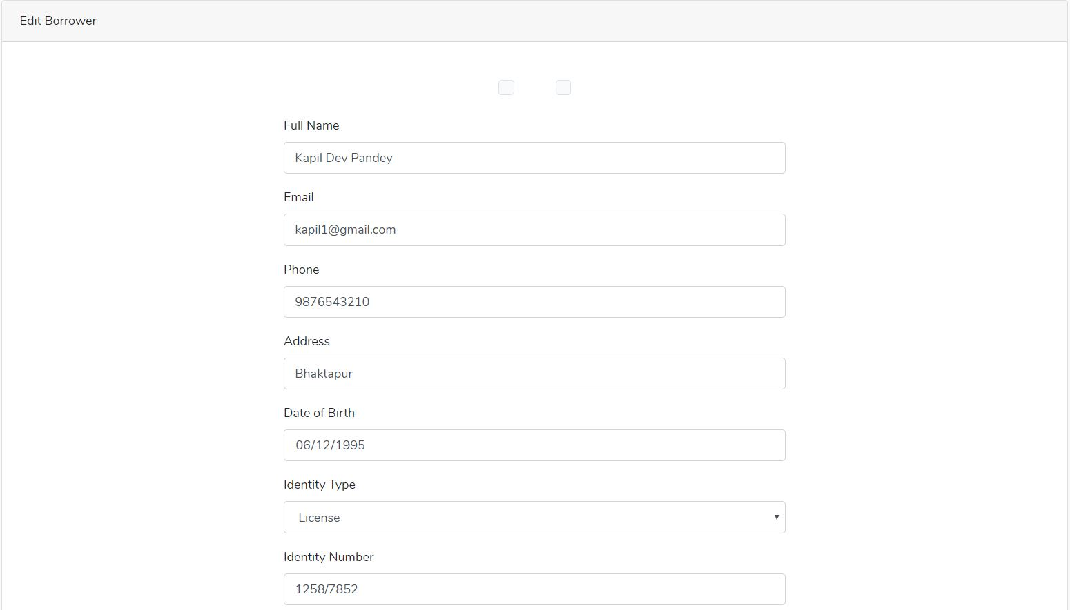



Figure update borrower form.

Admin can update the borrower details from that form.

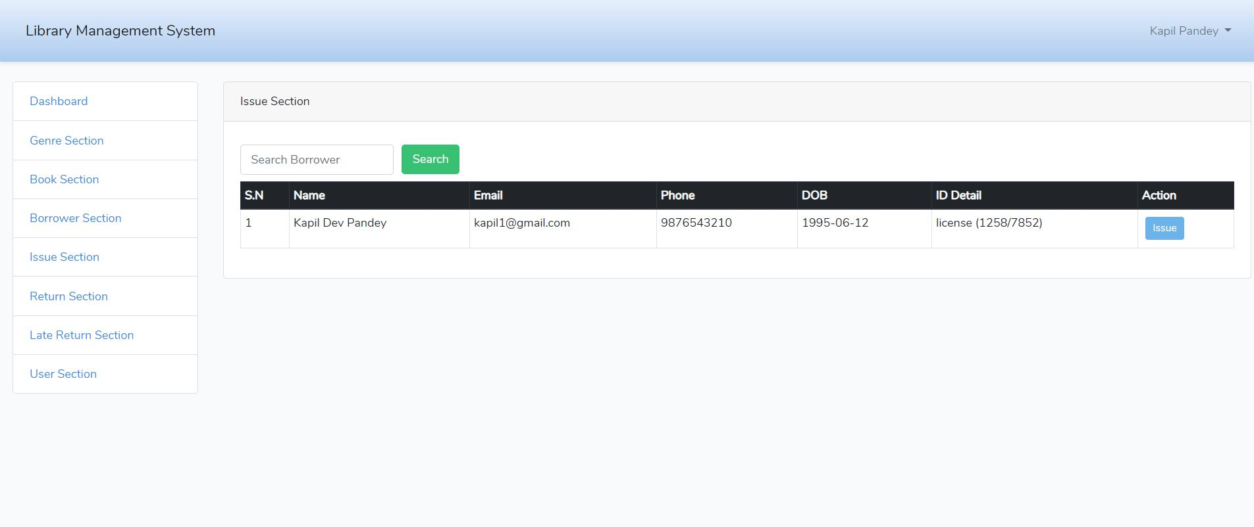

Figure issue section.

Admin can issue the book and search to whom book has been issued.

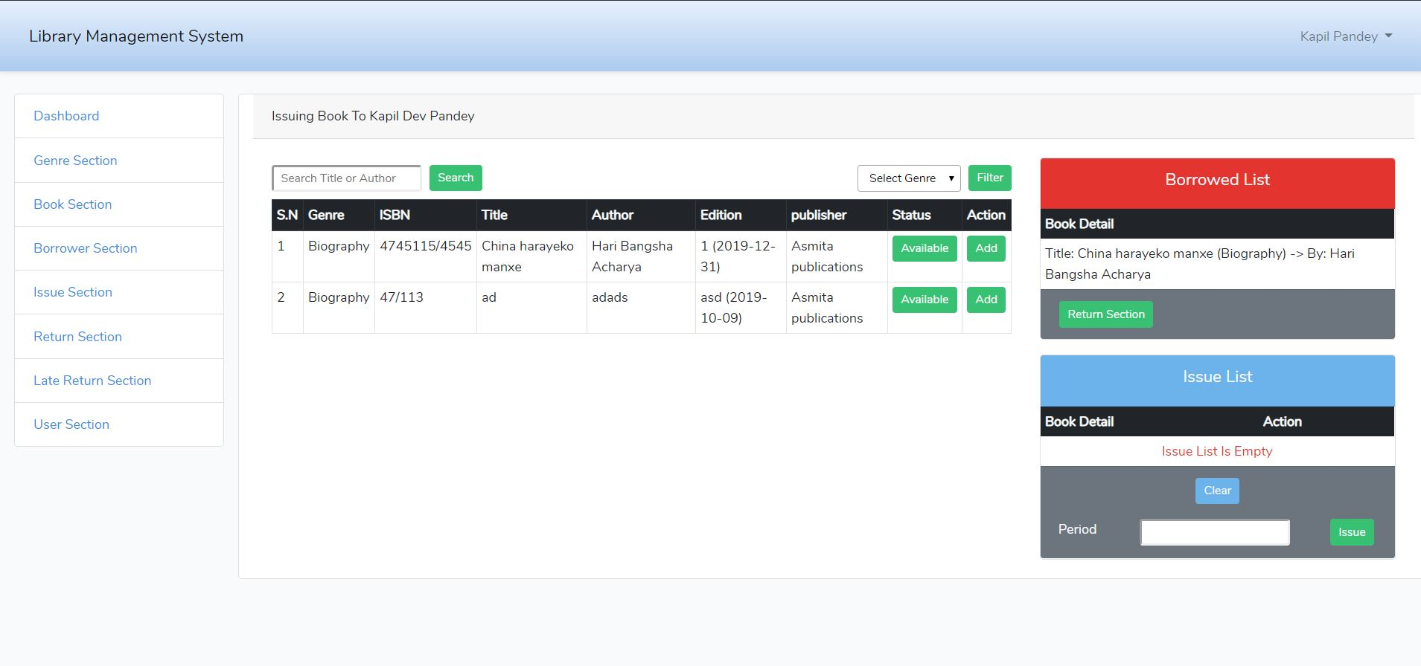

Figure issuing book detail.

From this page admin can know issuing book detail. He/she can search book according to title or author. Admin can check the availability of book. If it is available then he/she can issue the books to student. Admin can also view list of issue books issued by student. Admin can issue books to student for certain period of time if student fails to return then student will be charge fine for late return.

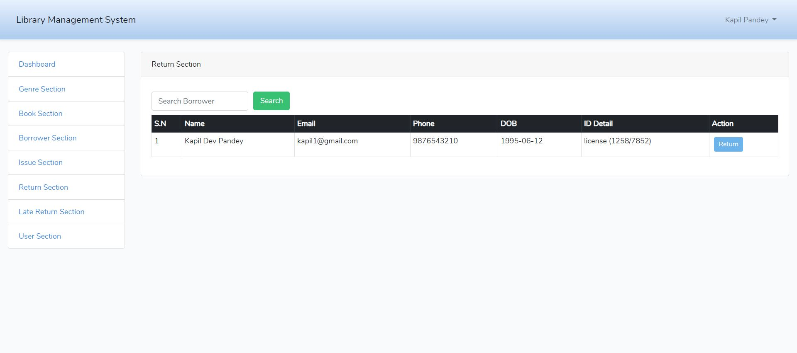

Figure return book

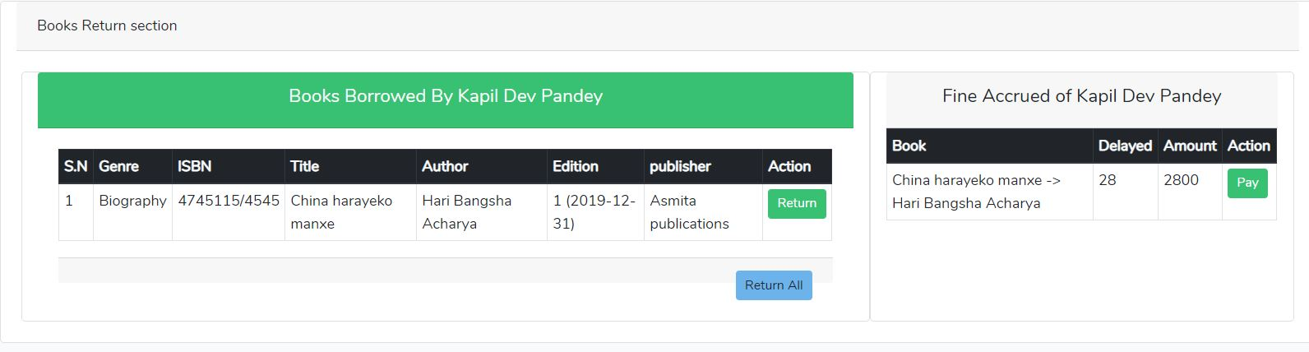

Figure fine accrued for late return

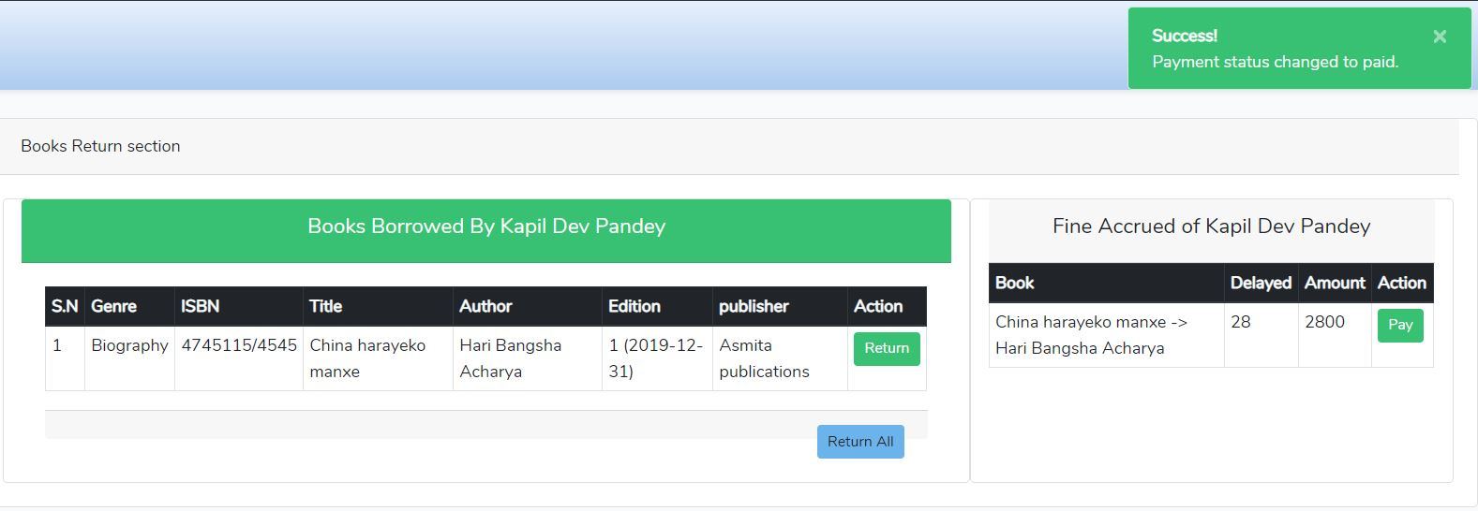

Figure after fine is paid then student can return book.

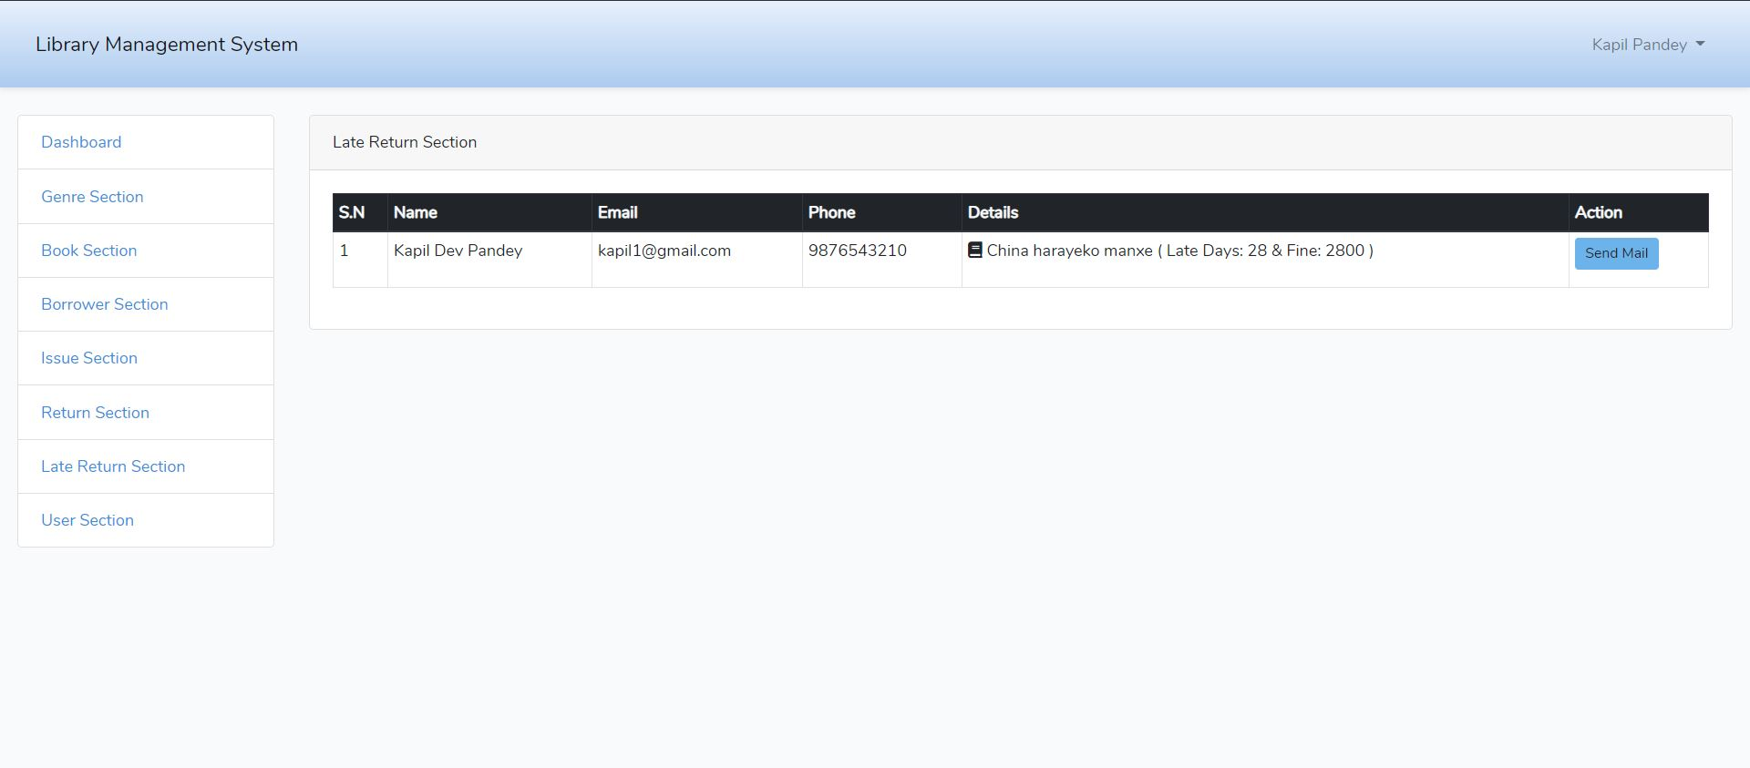

Figure late return.

If student fail to return book on time then from admin section mail will be sent to student mail for late return book and fine them.

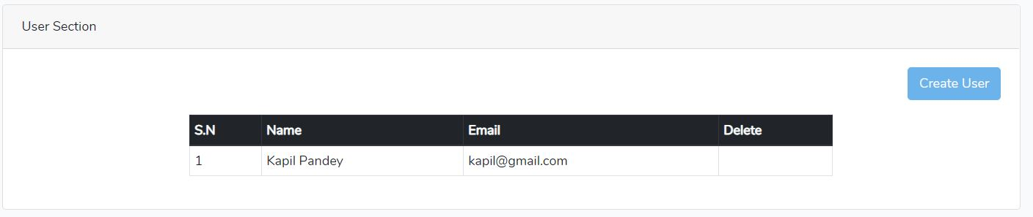

Figure user section

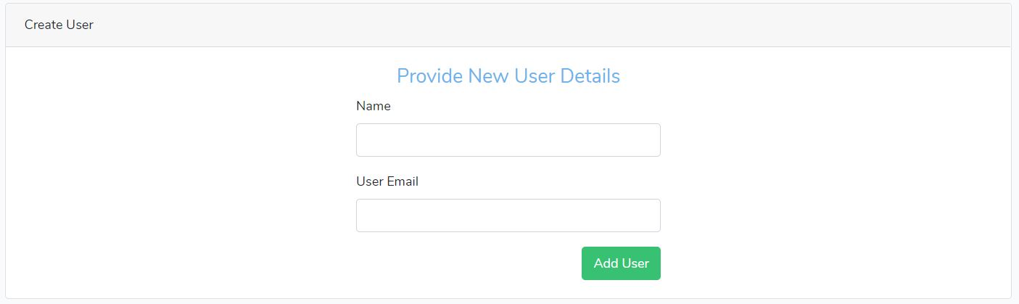

Figure can add new user from this form

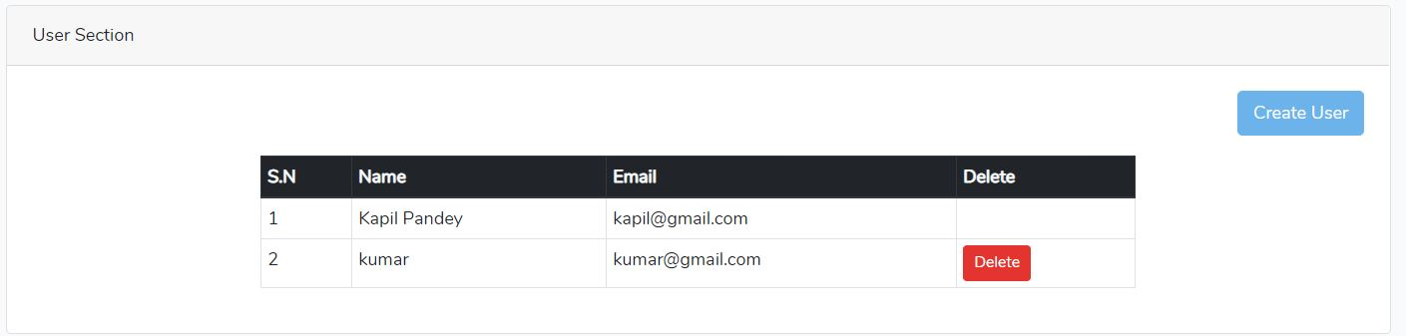

Figure can delete user from here.

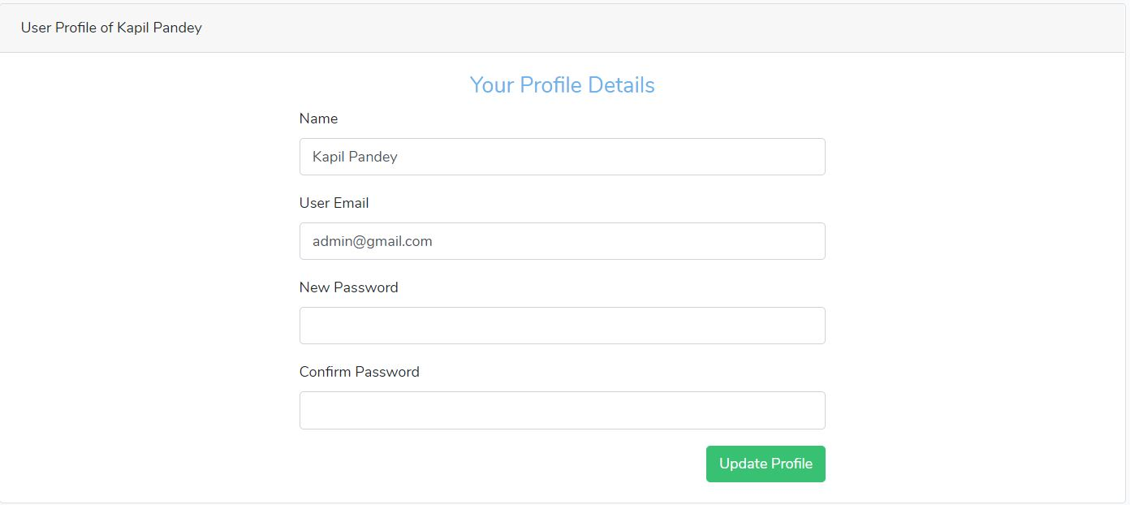

Figure admin update profile form.

# Chapter 7: Conclusion